 | COMMONWEALTH OF PENNSYLVANIA  PENNSYLVANIA PUBLIC UTILITY COMMISSION  P.O. BOX 3265, HARRISBURG, PA 17105-3265 | IN REPLY PLEASE REFER TO OUR FILE

October 8, 2013

MR PAUL E RUSSELL
ASSOCIATE GENERAL COUNSEL
PPL ELECTRIC UTILITIES CORPORATION
TWO NORTH NINTH STREET
ALLENTOWN PA 18101-1179

RE: Smart Meter Rider
Section 1307(e) Reconciliation Statement
For the twelve months ended June 30, 2013
M-2013-2382585

Dear Mr. Russell:

The Commission’s Bureau of Audits has reviewed the Smart Meter Rider (SMR) Section 1307(e) Reconciliation Statement for the twelve months ended June 30, 2013.

Based upon staff review, it appears that the SMR Section 1307(e) Reconciliation Statement, filed on July 31, 2013, is mathematically accurate and, accordingly shall be deemed an adequate filing within the meaning of Section 1307(e) of the Public Utility Code, 66 Pa. C.S. §1307(e).

Acceptance of the SMR Section 1307(e) Reconciliation Statement is expressly subject to such further review and revision as may be found necessary as the result of a subsequent Commission audit pursuant to Section 1307(d) of the Public Utility Code, 66 Pa. C.S. §1307(d), or some other proceeding. Acceptance shall not constitute approval of either the accuracy of the reported figures or the reasonableness of the underlying transactions.

This Secretarial Letter does not preclude a party from later filing a complaint on the substance or operation of the adjustment clause rate change filing. Any subsequent submissions to the Commission related to this docketed case should reference Docket No. M-2013-2382585.

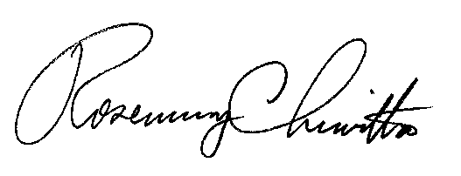
Sincerely,

Rosemary Chiavetta Secretary

Contact Person: Keith L. Mather
(717) 772-3440

