PENNSYLVANIA
PUBLIC UTILITY COMMISSION
Harrisburg, PA 17105-3265

Dawn Maiden :
:
v. : C-2013-2357904
:
Philadelphia Gas Works :

FINAL ORDER

In accordance with the provisions of Section 332(h) of the Public Utility Code, 66 Pa. C.S. §332(h), the decision of Administrative Law Judge Darlene R. Davis Heep dated August 26, 2013, has become final without further Commission action;

THEREFORE,

IT IS ORDERED:

1. That the motion of PGW to dismiss the Complaint of Dawn Maiden at Docket No. C-2013-2357904 is granted.

2. That the Formal Complaint filed by Dawn Maiden at Docket C-2013-2357904 is dismissed with prejudice for failure to prosecute.

3. That the case at Docket No. C-2013-2357904 be marked closed.

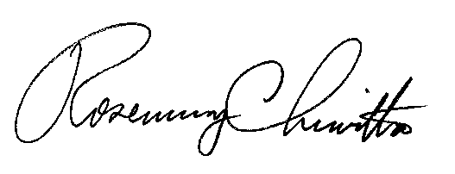
BY THE COMMISSION,

Rosemary Chiavetta
Secretary

(SEAL)

ORDER ENTERED: October 8, 2013

