PENNSYLVANIA
PUBLIC UTILITY COMMISSION
Harrisburg, PA 17105-3265

Zenola Davis :
:
v. : F-2013-2342367
:
Philadelphia Gas Works :

FINAL ORDER

In accordance with the provisions of Section 332(h) of the Public Utility Code, 66 Pa. C.S. §332(h), the decision of Administrative Law Judge Marta Guhl dated September 3, 2013, has become final without further Commission action;

THEREFORE,

IT IS ORDERED:

1. That the formal Complaint filed by Ms. Zenola Davis against Philadelphia Gas Works at Docket No. F-2013-2342367 is dismissed.

2. That the Secretary’s Bureau shall mark Docket No. F-2013-2342367 closed.
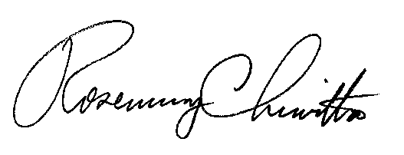
BY THE COMMISSION,

Rosemary Chiavetta
Secretary

(SEAL)

ORDER ENTERED: October 11, 2013

