PENNSYLVANIA
PUBLIC UTILITY COMMISSION
Harrisburg, PA 17105-3265

Timothy Ralph :
:
v. : F-2013-2362245 :
PECO Energy Company :

FINAL ORDER

In accordance with the provisions of Section 332(h) of the Public Utility Code, 66 Pa. C.S. §332(h), the decision of Administrative Law Judge Angela T. Jones dated August 16, 2013, has become final without further Commission action;

THEREFORE,

IT IS ORDERED:

1. That the Petition for Withdrawal of the formal Complaint filed by Timothy Ralph against PECO Energy Company at Docket No. F-2013-2362245 is granted.

2. That the Secretary’s Bureau is to mark this matter closed.
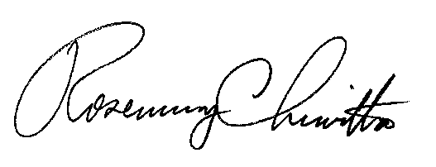
BY THE COMMISSION,

Rosemary Chiavetta
Secretary

(SEAL)

ORDER ENTERED: October 11, 2013

