PENNSYLVANIA
PUBLIC UTILITY COMMISSION
Harrisburg, PA 17105-3265

Bathsheba Willis :
:
v. : F-2013-2363228 :
PECO Energy Company :

FINAL ORDER

In accordance with the provisions of Section 332(h) of the Public Utility Code, 66 Pa. C.S. §332(h), the decision of Administrative Law Judge T. Angela Jones dated August 19, 2013, has become final without further Commission action;

THEREFORE,

IT IS ORDERED:

1. That the Petition for Withdrawal of the formal Complaint filed by Bathsheba Willis against PECO Energy Company at Docket No. F-2013-2363228 is granted.

2. That the Secretary’s Bureau is to mark this matter closed.
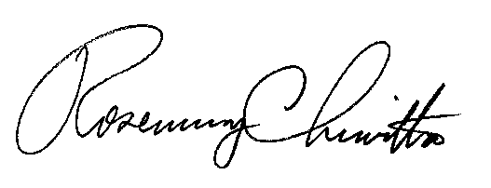
BY THE COMMISSION,

Rosemary Chiavetta
Secretary

(SEAL)

ORDER ENTERED: October 11, 2013

