PENNSYLVANIA
PUBLIC UTILITY COMMISSION
Harrisburg, PA 17105-3265

 | Public Meeting held November 14, 2013
Commissioners Present:

Robert F. Powelson, Chairman
John F. Coleman, Jr., Vice Chairman
James H. Cawley
Pamela A. Witmer
Gladys M. Brown

Pennsylvania Public Utility Commission, Bureau of Investigation and Enforcement  v.  UGI Utilities, Inc. – Gas Division | M-2013-2313375
OPINION AND ORDER

BY THE COMMISSION:

Before the Pennsylvania Public Utility Commission (Commission) for consideration and disposition is a Settlement Agreement (Settlement) filed on June 28, 2013, by the Commission’s Bureau of Investigation and Enforcement (I&E) and UGI Utilities, Inc. – Gas Division (UGI or Company) (collectively, Parties). Each Party also filed a Statement in Support of the Settlement.
History of the Proceeding

This matter concerns an informal investigation initiated by I&E at the request of the I&E Gas Safety Division (GSD) as a result of a gas ignition incident that occurred in Hazleton, Pennsylvania on June 5, 2012, and involved a UGI inspector and crew members of UGI’s third party contractor (Contractor). The GSD’s initial investigation of the incident suggested that a further investigation was warranted to determine whether the actions of UGI or the Contractor violated state regulations, federal regulations, and/or the Company’s operating procedures.

By letters dated December 3, 2012, January 8, 2013, and January 30, 2013, I&E requested that UGI provide responses to various data requests relating to the June 5, 2012 incident. The Company provided timely and complete responses. Based on its investigation, I&E concluded that UGI, by its own employees or the employees of its Contractor, violated state and federal regulations and its own operating procedures.

The Parties entered into negotiations and agreed to resolve this matter in accordance with the Commission’s policy to promote settlements at 52 Pa. Code § 5.231. The Parties filed the instant Settlement on June 28, 2013.

Background

I&E’s investigation stemmed from an incident that occurred on June 5, 2012, when a four-man crew employed by Contractor was working on a bare steel/cast iron main replacement project on West Holly Street in Hazleton, Pennsylvania. Specifically, the crew was inserting a new four-inch plastic pipe into an existing six-inch low-pressure bare steel main that would become a casing pipe. Settlement at 3. The work site was about 400 feet long, beginning at North Wyoming Street (the “Push Excavation”) and extending toward Laurel Street (the “Destination Excavation”). Id. at 3-4.

UGI’s operational procedures provide that insertion of the pipe required that the main be cut with a mechanical saw after the gas flow in the main was stopped. In this instance, the Contractor’s employees inserted a single stopper into the main on each end of the affected part of the gas main to stop the gas flow. The UGI inspector at the Destination Excavation observed this “stop off.”

The Contractor’s foreman was planning to cut the bare steel pipe with a four wheel cutter, but based on the restricted clearance caused by a sewer lateral adjacent to the pipe, he elected to use an electric reciprocating saw. The foreman was aware that some gas was bypassing through the stoppers, and he instructed one of the crew members to introduce air from an air knife under low flow to the area where the saw cut was being made.

The process of the crew members cutting the pipe with an electric saw and blowing air into that work area resulted in a spark that created an ignition of natural gas. The gas ignition caused a minor flash-burn injury to the face of the Contractor foreman. Another Contractor employee put out the flame with a fire extinguisher. The incident did not result in injury to any person other than the Contractor foreman or in any property damage.

The UGI inspector was about one city block away at the Destination Excavation when the incident occurred, and he arrived at the incident location in about one minute. Id. at 4. Within approximately twenty minutes of the incident, a clamp was installed over the partially cut section of the gas main to stop the gas from escaping.

The Commission was notified within an hour of the incident. UGI Operations and Safety and Compliance Staff arrived at the incident site shortly thereafter. UGI and the GSD personnel questioned the UGI inspector. UGI Management and the Contractor, in coordination with the GSD, conducted subsequent investigations. Id. at 5.
If this matter had been litigated, I&E would have alleged that UGI violated Section 605(a) of Title 49 of the Code of Federal Regulations, 49 C.F.R. § 192.605(a), and Sections 59.11 and 59.33 of the Commission’s Regulations, 52 Pa. Code §§ 59.11 and 59.33, as follows:
a. UGI failed to comply with its Gas Operations Manual, Procedure Number 70.90.10, Prevention of Accidental Ignition, in that UGI’s Contractor, with a UGI inspector on site, used an electric saw to make the necessary cut to the distribution main in an environment that contained or could contain flammable gas.

b. UGI failed to comply with its Gas Operations Manual, Procedure Number 60.100.40, Section 3.4, in that UGI’s Contractor, with a UGI inspector on site, used a single stopper at each end of the main section being cut instead of two stoppers at each end.

c. UGI failed to comply with its Gas Operations Manual, Procedure Number 60.100.40, Section 7.12 and Manual of Standard Procedures, Sections 8.1.1 and 8.1.2 in that UGI’s Contractor, with a UGI inspector on site, failed to purge gas from the main section of the pipe to be cut.

d. UGI failed to comply with its Manual of Standard Procedures, Section 8.1.2 in that UGI’s Contractor, with a UGI inspector on site, failed to use safety vents to exhaust discharged gas from the main section of the pipe to be cut.

e. UGI failed to comply with its Gas Operations Manual, Procedure Number 70.90.10, Section 4.0, in that UGI’s Contractor, with a UGI inspector on site, failed to ground/bond the main section prior to cutting the pipe.

f. UGI failed to comply with its Gas Operations Manual, Procedure Number 60.100.40, Sections 3.3, 7.1, 7.8, 7.11 and UGI’s Manual of Standard Procedures, Section 8.1.3 in that UGI’s Contractor, with a UGI inspector on site, failed to install pressure gauges on each side of the stopper setup on the pipe to be cut.

g. I&E would have further alleged that UGI should have classified the incident in question as a “reportable incident” as that term is defined at 52 Pa. Code
§ 59.11(b) and, as a result, UGI should have timely filed a written accident report, as required to be filed with the Commission within [thirty] days of the occurrence.

Settlement at 7-8.

Had this matter been fully litigated, UGI would have denied or answered and defended against some or all of the above-stated allegations. Id. at 8.

Terms of the Settlement Agreement

The Parties entered into the Settlement to resolve this matter fully and completely without litigation in a formal proceeding. Settlement at 9. The Settlement provides that it resolves with prejudice all issues related to the informal investigation. Id. at 11.

The Parties have agreed to the following Settlement terms:

a. UGI will pay a civil penalty of ninety-six thousand dollars ($96,000.00) to resolve the alleged violations identified by I&E in its informal investigation. Said payment shall be made by certified check payable to “Commonwealth of Pennsylvania” and forwarded to the Commission through the prosecuting attorney within thirty (30) days of the date of the Order approving this Settlement. UGI shall not recover any portion of this monetary settlement amount from its customers in any future ratemaking claim or any other manner whatsoever.

b. UGI has taken or will take corrective action and has implemented revisions to its operating procedures which will act as safeguards against a similar incident occurring in the future. The pertinent actions taken by UGI and Contractor are set forth in Paragraph 21, above.

Id. at 9.

The corrective actions described above, and as set forth in Paragraph 21 of the Settlement, consist of the following:

a. UGI supervisors met with and briefed UGI’s Hazleton area employees and Contractor employees regarding the importance of following the Company’s operational procedures and communicated that deviation from these procedures would not be tolerated. Topics covered include Prevention of Accidental Ignition 70.90.10, Tapping and Stopping off Low Pressure Mains Using Bags or Low Pressure Stoppers 60.100.40 and UGI’s Job Plan.

b. UGI administered appropriate disciplinary action regarding the UGI inspector, including a thirty (30) day suspension and reduction in grade. The employee subsequently retired.

c. UGI met with the Contractor’s management, discussed the facts of the matter, emphasized the importance of following the Company’s operational procedures and communicated that deviation from these procedures would not be tolerated. The Contractor foreman was terminated from his employment with Contractor.

Id. at 5-6.

In consideration of UGI’s agreement to pay a civil penalty and other non-monetary relief, as specified in the Settlement, I&E agrees to forebear from prosecuting any formal complaint that relates to the incident and the related conduct of the Company, its employees, and Contractor, as described in the Settlement. Id. at 9. The Parties state that nothing contained in the Settlement shall adversely affect the Commission’s authority to receive and resolve any informal or formal complaints filed by any affected party with respect to the incident, except that no further sanctions may be imposed by the Commission for any actions identified in the Settlement. Id. at 9-10. Additionally, none of the provisions of the Settlement or the statements in the Settlement shall be considered an admission of any fact or culpability. As the Settlement does not make any findings of fact or conclusions of law, the Parties intend that the Settlement shall not be admitted as evidence in any potential civil proceeding involving this matter. Id. at 11.

The Settlement is conditioned upon the Commission’s approval of its terms, without modification. The Parties reserve the right to withdraw from the Settlement if it is modified. Id. at 10.

Discussion

We note that, consistent with Section 5.231 of our Regulations, 52 Pa. Code § 5.231, it is our policy to promote settlements. However, before taking final action on the proposed Settlement, we must first seek public comment pursuant to Section 3.113(b)(3) of our Regulations, 52 Pa. Code § 3.113(b)(3).

Conclusion

Before issuing a decision on the merits of the proposed Settlement, consistent with Section 3.113(b)(3) of our Regulations, 52 Pa. Code § 3.113(b)(3), we are providing an opportunity for interested parties to file comments; THEREFORE,

IT IS ORDERED:

1. That this Opinion and Order, together with the attached Settlement Agreement and the Statements in Support thereof, shall hereby be entered for comments.

2. That a copy of this Opinion and Order, together with the attached Settlement Agreement and the Statements in Support thereof, shall be served on the Office of Consumer Advocate, the Office of Small Business Advocate, and the Bureau of Investigation and Enforcement.

3. That comments to this Opinion and Order, together with the Settlement Agreement and the Statements in Support thereof, will be considered timely if filed within twenty (20) days of the date of entry of this Opinion and Order.

4. That, subsequent to the Commission’s review of the comments filed in this proceeding, a final Opinion and Order will be issued.

 BY THE COMMISSION,

Rosemary Chiavetta
Secretary
(SEAL)

ORDER ADOPTED: November 14, 2013

ORDER ENTERED: November 14, 2013

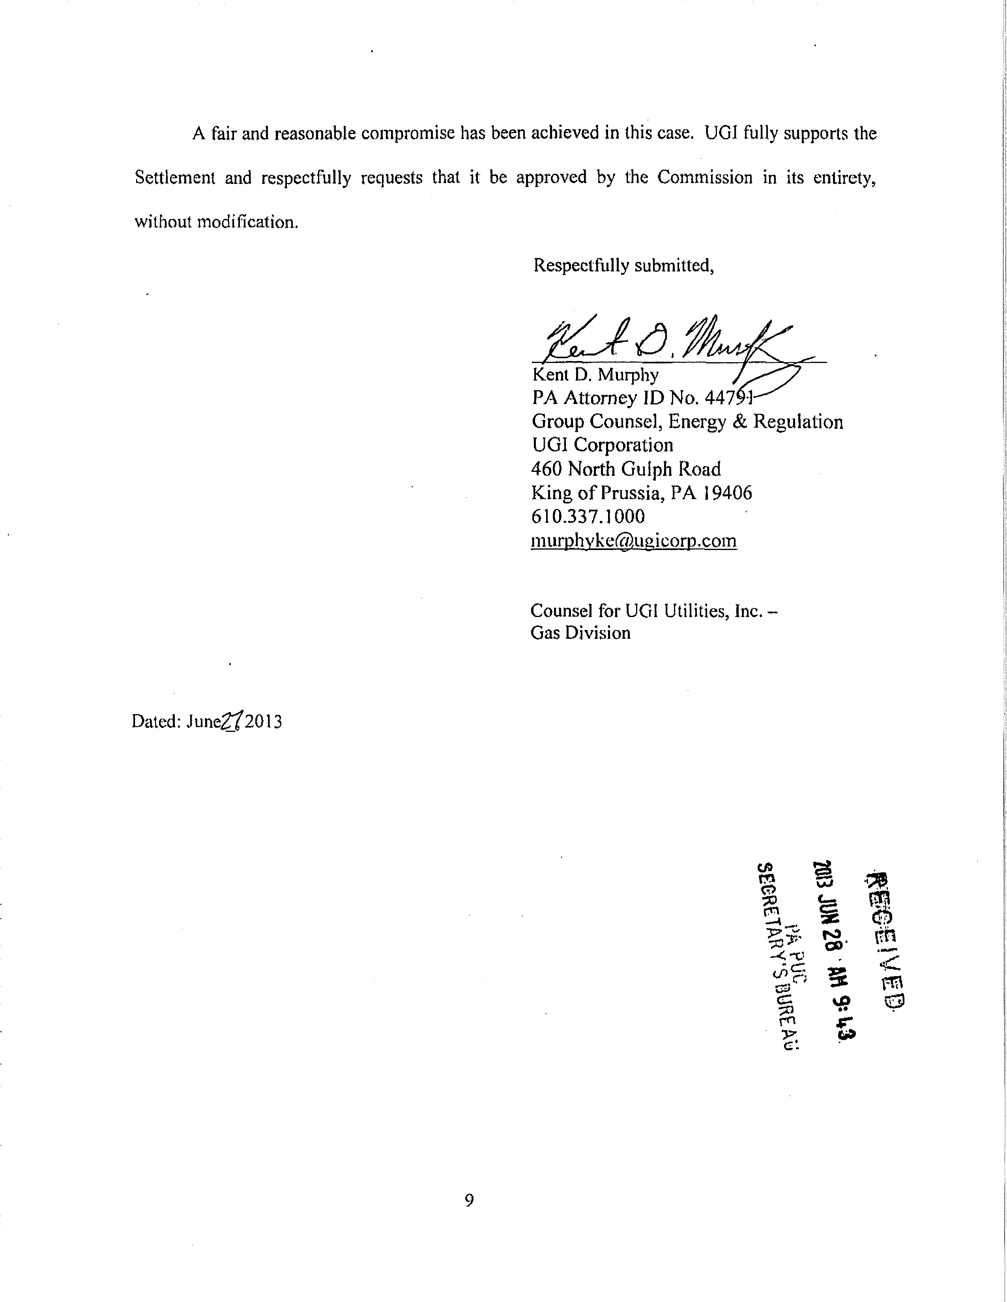

The Incident Investigation Report prepared by the Contractor indicated that the foreman was treated at Hazleton Hospital, where he was given an ointment to apply to his facial burns and a prescription for pain medication.

