BEFORE THE

PENNSYLVANIA PUBLIC UTILITY COMMISSION

Letter of Notification of PPL Electric : A-2013-2352732
Utilities Corporation, filed pursuant to :
52 Pa. Code Chapter 57 Subchapter G, with :
Respect to the Reconstruction of the St. Johns :
-Freeland 69 kV Transmission Tie Line in :
Butler and Foster Townships, Luzerne County :
Pennsylvania :

interim order
setting litigation schedule

Please be advised that the following litigation schedule due dates are established in this matter:

PPL Written Direct Testimony January 13, 2014

Other Parties Written Direct Testimony February 10, 2014

Written Rebuttal Testimony March 5, 2014

Written Surrebuttal Testimony March 25, 2014

Evidentiary Hearings held in Scranton April 8–9, 2014

Initial Briefs May 9, 2014

Reply Briefs June 2, 2014

Date: January 7, 2014 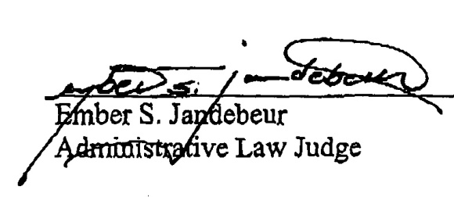

A-2013-2352732 - APPLICATION OF PPL ELECTRIC UTILITIES CORPORATION
JOHN H ISOM ESQUIRE
CHRISTOPHER T WRIGHT ESQUIRE
POST & SCHELL
12TH FLOOR
17 NORTH SECOND STREET
HARRISBURG PA 17101-1601
717-612-6032
E-Serve
MICHAEL AND SHARON LEE SABIA
186 N OLD TURNPIKE RD
DRUMS PA 18222
570-459-0479
E-Serve
EDWARD AND DEBORAH TELATOVICH
168 NORTH OLD TURNPIKE ROAD
BOX 112
ST JOHNS PA 18247
570-579-4309

