PENNSYLVANIA
PUBLIC UTILITY COMMISSION
Harrisburg, PA 17105-3265

Leslie Janet Pellot :
:
v. : C-2013-2365592
:
PECO Energy Company :

FINAL ORDER

In accordance with the provisions of Section 332(h) of the Public Utility Code, 66 Pa. C.S. §332(h), the decision of Administrative Law Judge Angela T. Jones dated December 9, 2013, has become final without further Commission action;

THEREFORE,

IT IS ORDERED:

1. That the formal Complaint filed by Leslie Janet Pellot against PECO Energy Company at Docket No. C-2013-2365592 is denied.

2. That the Secretary mark this docket closed.

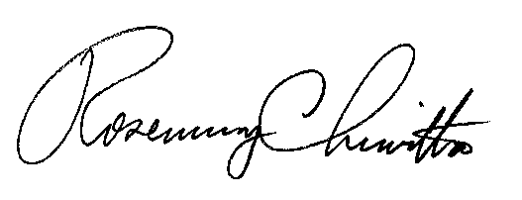
BY THE COMMISSION,

Rosemary Chiavetta
Secretary

(SEAL)

ORDER ENTERED: January 24, 2014

