 | Customer Name and Service Address  Customer Sample  100 Sample Drive  Sample Town, PA 12345-6789 | Account Number: 9999999999
Rate: RS-Residential Service
Date Prepared: 10/02/13

Meter Reading Usage Information |  | Summary of CAP Bill
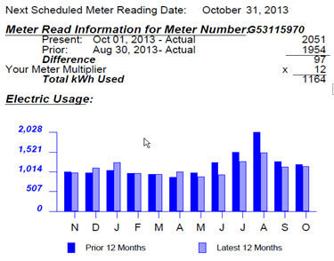 |  | ACTUAL METER READING BILL  Based on your average usage this CAP year, you may exceed the CAP  Credit maximum by 12/20/13. If you exceed the maximum CAP credit, you will  be required to pay the full budget amount each month until your yearly CAP  Credit amount is reset on 3/5/14.  Total Account Balance
   | DAYS IN BILLING PERIOD
   | N | D | J | F | M | A | M | J | J | A | S | O
   | 32 | 30 | 33 | 29 | 29 | 29 | 32 | 30 | 29 | 32 | 30 | 32
   | 30 | 30 | 33 | 29 | 29 | 32 | 29 | 30 | 31 | 31 | 29 | 32
  Prior Billing Information
  Amount of Last Bill | $161.00
  You Paid | 161.00
  Prior CAP Balance |  | $0.00
  Current Charges
  Current DLC Budget | $130.00
  CAP Discount | -52.00
  You Owe 60% of Budget |  | $78.00
  Total CAP Charges Owed |  | $78.00
  Maximum Annual CAP Credit | $560.00
  Annual CAP Credit Used to Date | 420.00
  Remaining CAP Credit Available | $140.00
  Last Account Balance | 422.46
  Basic Service Charges | 135.96
  You Paid | -161.00
  Cancelled Debt from CAP Payment | -4.41
  CAP Discount | -52.00
  Total Account Balance |  | $341.01
  Your total account balance will be DUE if you default from the CAP program.
Estimated Gross  Receipts Tax | Estimated PA  State Taxes | Payment Due | Amount Due
$8.02 | $9.25 | Oct 23, 2013 | $78.00
Please return this portion with your payment. Make payment payable to Duquesne Light Company.
Please enclose check facing forward

Account Number PLEASE PAY BY OCT 23, 2013
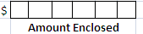
9999999999 $78.00

Customer Sample
100 Sample Drive
Sample Town, PA 12345-6789
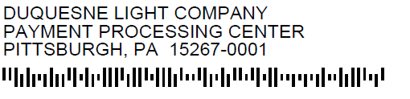

9999999999X 00000000078003 00000000078003 00000000078003

