 | Customer Name and Service Address  Customer Sample  100 Sample Drive  Sample Town, PA 12345-6789 | Account Number: 9999999999
Rate: RS-Residential Service
Date Prepared: 10/02/13

Meter Reading Usage Information |  | Summary of CAP Bill
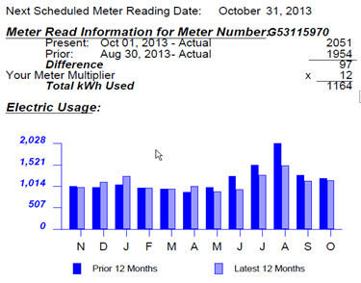 |  | ACTUAL METER READING BILL  You have exceeded the CAP Credit maximum. You will be required to pay  the full budget amount each month until your yearly CAP Credit is reset on  3/5/14.  Total Account Balance
   | DAYS IN BILLING PERIOD
   | N | D | J | F | M | A | M | J | J | A | S | O
   | 32 | 30 | 33 | 29 | 29 | 29 | 32 | 30 | 29 | 32 | 30 | 32
   | 30 | 30 | 33 | 29 | 29 | 32 | 29 | 30 | 31 | 31 | 29 | 32
  Prior Billing Information
  Amount of Last Bill | $161.00
  You Paid | 161.00
  Prior CAP Balance |  | $0.00
  Current Charges
  Current DLC Budget | $130.00
  CAP Discount | 0.00
  You Owe 100% of Budget |  | $130.00
  Total CAP Charges Owed |  | $130.00
  Maximum Annual CAP Credit | $560.00
  Annual CAP Credit Used to Date | 580.00
  Remaining CAP Credit Available | $00.00
  Last Account Balance | 422.46
  Basic Service Charges | 135.96
  You Paid | -161.00
  Cancelled Debt from CAP Payment | -4.41
  Total Account Balance |  | $393.01
  Your total account balance will be DUE if you default from the CAP program.
Estimated Gross  Receipts Tax | Estimated PA  State Taxes | Payment Due | Amount Due
$8.02 | $9.25 | Oct 23, 2013 | $130.00
Please return this portion with your payment. Make payment payable to Duquesne Light Company.
Please enclose check facing forward

Account Number PLEASE PAY BY OCT 23, 2013
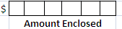
9999999999 $130.00

Customer Sample
100 Sample Drive
Sample Town, PA 12345-6789
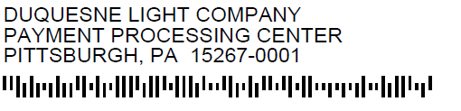

9999999999X 00000000130003 00000000130003 00000000130003

