PENNSYLVANIA
PUBLIC UTILITY COMMISSION
Harrisburg, PA 17105-3265

Public Meeting held May 22, 2014

Commissioners Present:

Robert F. Powelson, Chairman
John F. Coleman, Jr., Vice Chairman
James H. Cawley
Pamela A. Witmer
Gladys M. Brown

Pennsylvania Public Utility Commission,  Law Bureau Prosecutory Staff  v.  Duquesne Light Company |  | M-2014-2165364

Opinion and Order

BY THE COMMISSION:

Before the Pennsylvania Public Utility Commission (Commission) for consideration and disposition is a proposed Settlement Agreement (Settlement) filed on April 1, 2014, by the Commission’s Law Bureau Prosecutory Staff (LBPS) and Duquesne Light Company (Duquesne or Company) (collectively, the Parties), with respect to an Informal Investigation conducted by LBPS. Contained within the body of the Settlement is a Statement in Support. The Parties submit that the Settlement is in the public interest and is consistent with the Commission’s Policy Statement at 52 Pa. Code § 69.1201, Factors and standards for evaluating litigated and settled proceedings involving violations of the Public Utility Code and Commission regulations—statement of policy. Settlement at 5-8. We will issue the Settlement for comment.

History of the Proceeding

On March 19, 2010, LBPS initiated an informal investigation of Duquesne’s real property and disposition practices. In particular, LBPS investigated the acquisition and disposition of the real property for the “Moon-Sewickley tap project, Moon Township, Allegheny County, Pennsylvania.” Settlement at 1-2. During its review, LBPS investigated whether this transaction, and the Company’s practices and procedures for acquiring and disposing of real property and obtaining all necessary regulatory approvals for such transactions, were in compliance with the Public Utility Code (Code), 66 Pa. C.S. §§ 101, et seq., and the Commission’s Regulations, 52 Pa. Code §§ 1.1, et seq.

The Parties entered into negotiations and agreed to resolve this matter in accord with the Commission’s policy to promote settlements at 52 Pa. Code § 5.231. Settlement at 1. The Parties filed the instant Settlement on April 1, 2014. LBPS concurrently filed a Report of Law Bureau Prosecutory Staff’s Informal Investigation of Duquesne Light Company’s Real Property Acquisition and Disposition Practices (Report) on April 1, 2014.

Background

By letter dated March 19, 2010, LBPS initiated its investigation of Duquesne related to the Company’s acquisition and disposition of real property for the Moon-Sewickley tap project. Additionally, LBPS’ investigation focused on Duquesne’s general practices and procedures pertaining to real property disposition and acquisition to evaluate compliance with the Code and the Commission’s Regulations. Settlement at 1-2.

In 1914 and 1915, Duquesne acquired rights-of-way (Easement) across properties located in Moon Township and installed a transmission line and transmission facilities within the Easement in the 1920s. A portion of the properties was later subdivided into developments with each owner taking title subject to Duquesne’s Easement. Duquesne’s high tension power line crossed the Property in this proceeding subject to the Easement. Report at 1-2.

Beginning around 2007, Duquesne proposed to upgrade its electric transmission lines by building an extension from Moon Township, across the Ohio River, and into Sewickley Borough (Sewickley Loop Project). The Sewickley Loop Project was designed to connect with the existing transmission line and tower located within the Easement on the Property in Moon Township. In 2008, Duquesne met with the daughter of the Property owners to discuss the installation of two new towers within the existing Easement on the Property and the connection of the existing transmission line to the Company’s new river-crossing towers. Because the existing Easement across the Property was insufficient to properly connect the existing transmission line to the new river-crossing towers, Duquesne proposed acquiring an additional right-of-way from the Property owners. Id. at 2-3.

Duquesne successfully obtained a new right-of-way from Sewickley Borough to facilitate the Sewickley Loop Project. Report at 8. However, the Company was unable to negotiate the acquisition of an expanded right-of-way from the Property owners in Moon Township. It later purchased the entire Property outright. On January 25, 2010, Duquesne sold the Property to another party. In the deed to the new owner, Duquesne reserved its initial Easement rights and an expanded easement of one hundred feet in width for the Sewickley Loop Project. Duquesne did not seek Commission approval for either the initial acquisition or the later transfer of the Property. Report at 3-5.

LBPS alleged that Duquesne acquired and disposed of the Property without obtaining a Certificate of Public Convenience (Certificate), in violation of Section 1102(a)(3) of the Code, 66 Pa. C.S. § 1102(a)(3). In response, the Company averred that a Certificate was not required under the facts and circumstances of this case. Duquesne further alleged “that its actions with respect to this property were in full accordance with long-standing Commission practice and precedent.” Settlement at 3.

In its Report, LBPS also referenced Section 57.91 of our Regulations, 52 Pa. Code § 57.91, which requires a public utility to provide a specific written notice at least fifteen days before its employees or agents are permitted to communicate in any manner with a property owner for the purpose of negotiating the acquisition of a transmission right-of-way. LBPS alleged that Duquesne failed to provide to the original Property owners in Moon Township or the Borough of Sewickley the written notice required by Section 57.91. According to LBPS, the Company did not contest this violation. Report at 8.

Additionally, LBPS alleged in its Report that Duquesne used a “straw person” or “straw man” to purchase real estate and gave as an example the purchase of property on Chadwick Street in Sewickley Borough. Although LBPS did not find that Duquesne’s use of a “straw man” to purchase real estate was illegal per se, it concluded that utilities, in the interest of transparency and full disclosure of their dealings, must comply with Section 1102(a) of the Code and 52 Pa. Code § 57.91. Report at 12-13.

As a result of negotiations between LBPS and Duquesne, the Parties have agreed to resolve their differences and urge the Commission to approve the Settlement as being in the public interest. Settlement at 2, 4. In the Settlement, LBPS credits Duquesne with fully cooperating and complying with the LBPS’s investigation and requests for documentation. Id. at 2.

Terms of the Settlement

Pursuant to the Settlement, the Parties agree to settle “without further litigation all matters related to Duquesne’s real property acquisition and disposition for the Moon-Sewickley tap project, and all other Duquesne acquisition and sales of property through December 31, 2012.” Settlement at 2-3.
Under the terms of the Settlement, Duquesne will pay a civil penalty of $2,500. In addition, the Company agrees to pay $17,500 to the Dollar Energy Fund. Id. at 4.

Duquesne will also follow the notification requirements of 52 Pa. Code § 57.91 regardless of whether the property is subject to condemnation. Additionally, the Company agrees not to employ straw purchasers when acquiring any interest in real property for the siting and construction of overhead transmission lines. Settlement at 4.

If the Commission substantially modifies the terms of the Settlement, the Parties are permitted to petition the Commission for a hearing. Id. In that event, any Party may withdraw from the Settlement within ten business days of any Commission Order making substantive modifications in the Settlement. Id.

Discussion

Pursuant to our Regulation at 52 Pa. Code § 5.231, it is the Commission’s policy to promote settlements. The Commission must, however, review proposed settlements to determine whether the terms are in the public interest. Pa. PUC v. Philadelphia Gas Works, Docket No. M-00031768 (Order entered January 7, 2004).

Conclusion

Before issuing a decision on the merits of the Settlement, and consistent with the requirement of 52 Pa. Code § 3.113(b)(3), we are providing an opportunity for interested parties to file comments regarding the Settlement; THEREFORE,

IT IS ORDERED:

1. That this Opinion and Order, together with the attached Settlement Agreement, shall be issued for comments by any interested party.

2. That a copy of this Opinion and Order, together with the attached Settlement Agreement, shall be served on the Office of Consumer Advocate and the Office of Small Business Advocate.

3. That comments regarding the attached Settlement Agreement will be considered timely if filed within twenty (20) days of the date of entry of this Opinion and Order.

4. That, subsequent to the Commission’s review of comments filed in this proceeding, an Opinion and Order will be issued.


BY THE COMMISSION,

Rosemary Chiavetta
Secretary
(SEAL)
ORDER ADOPTED: May 22, 2014
ORDER ENTERED: May 22, 2014

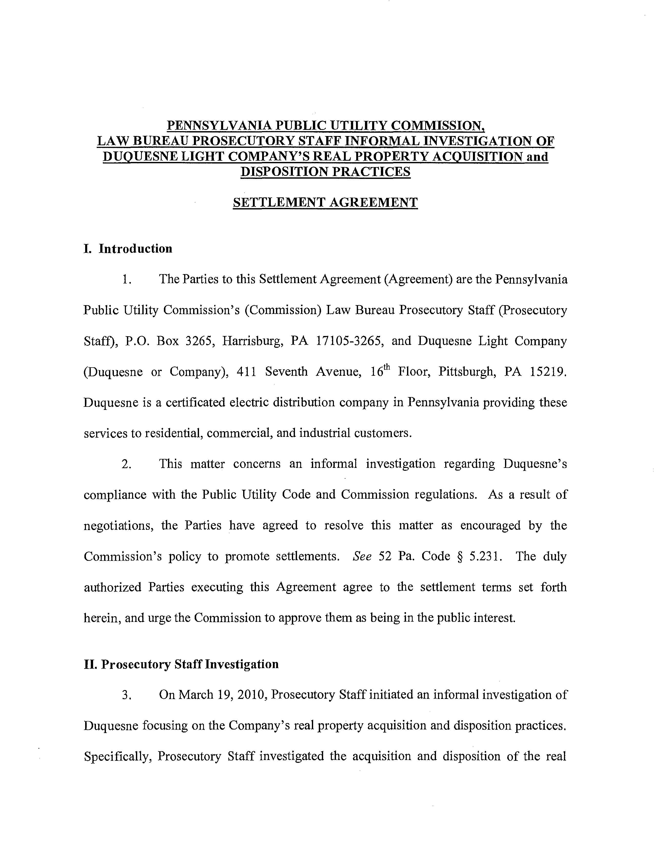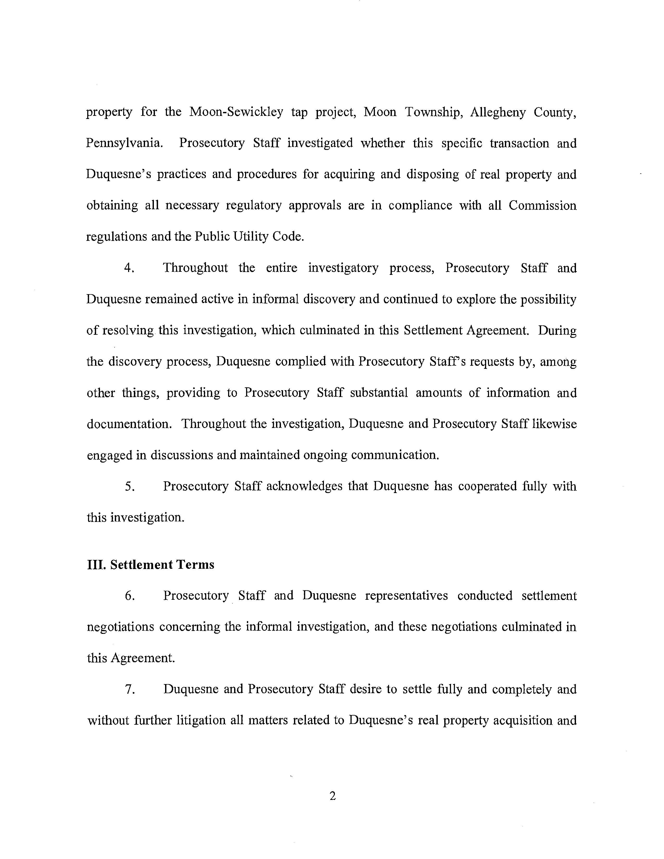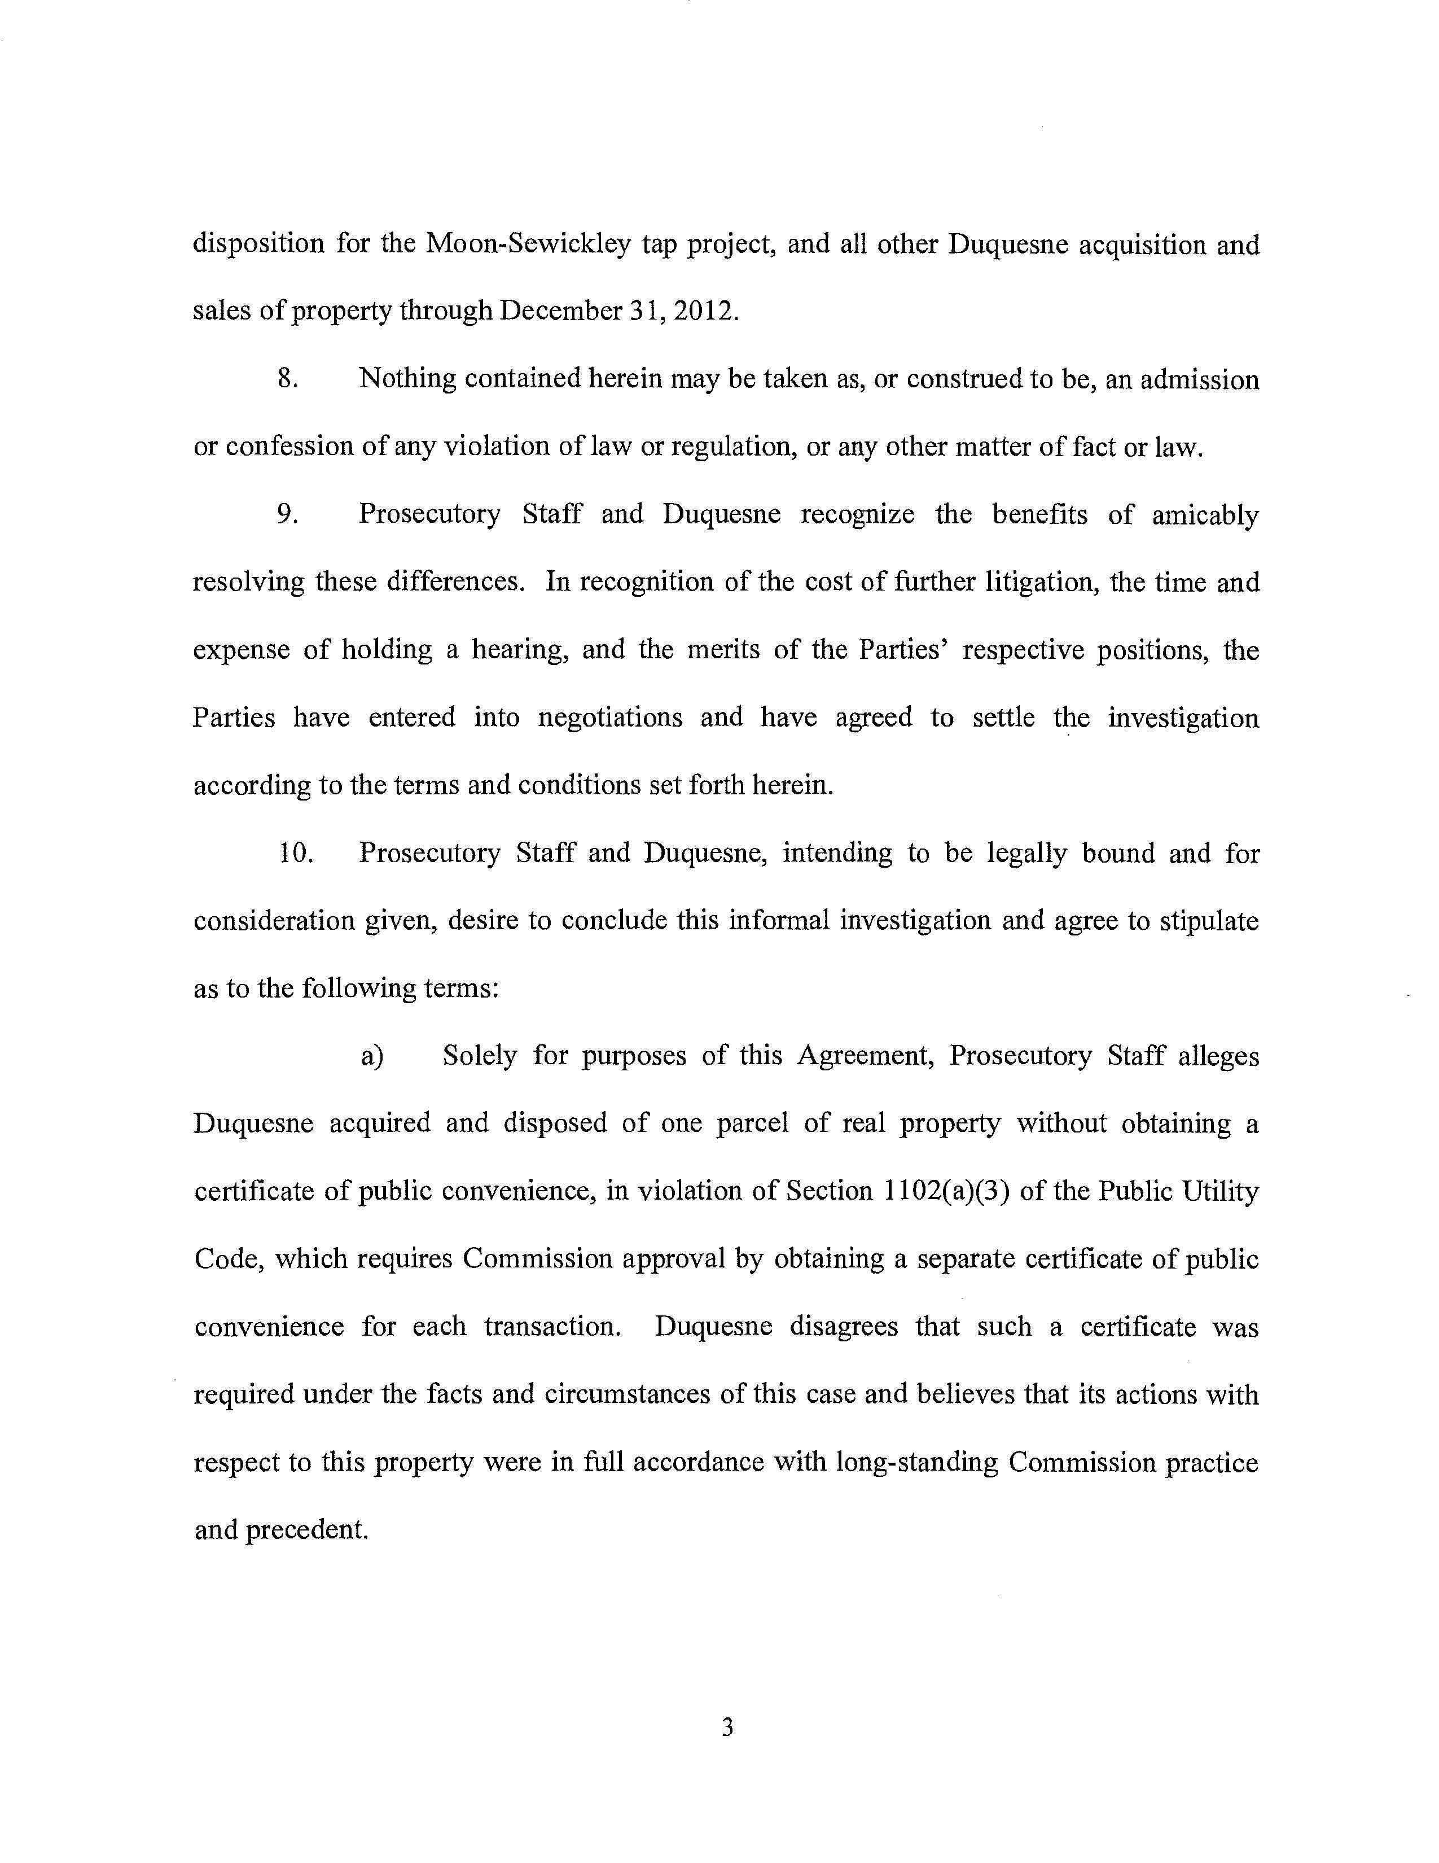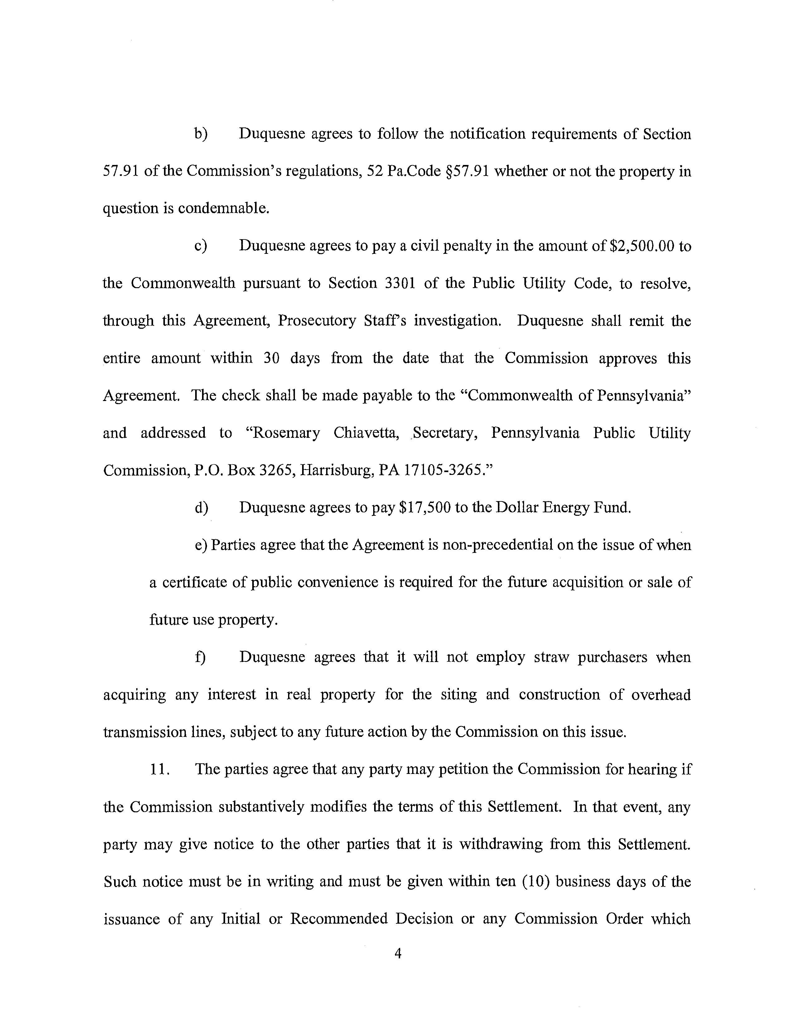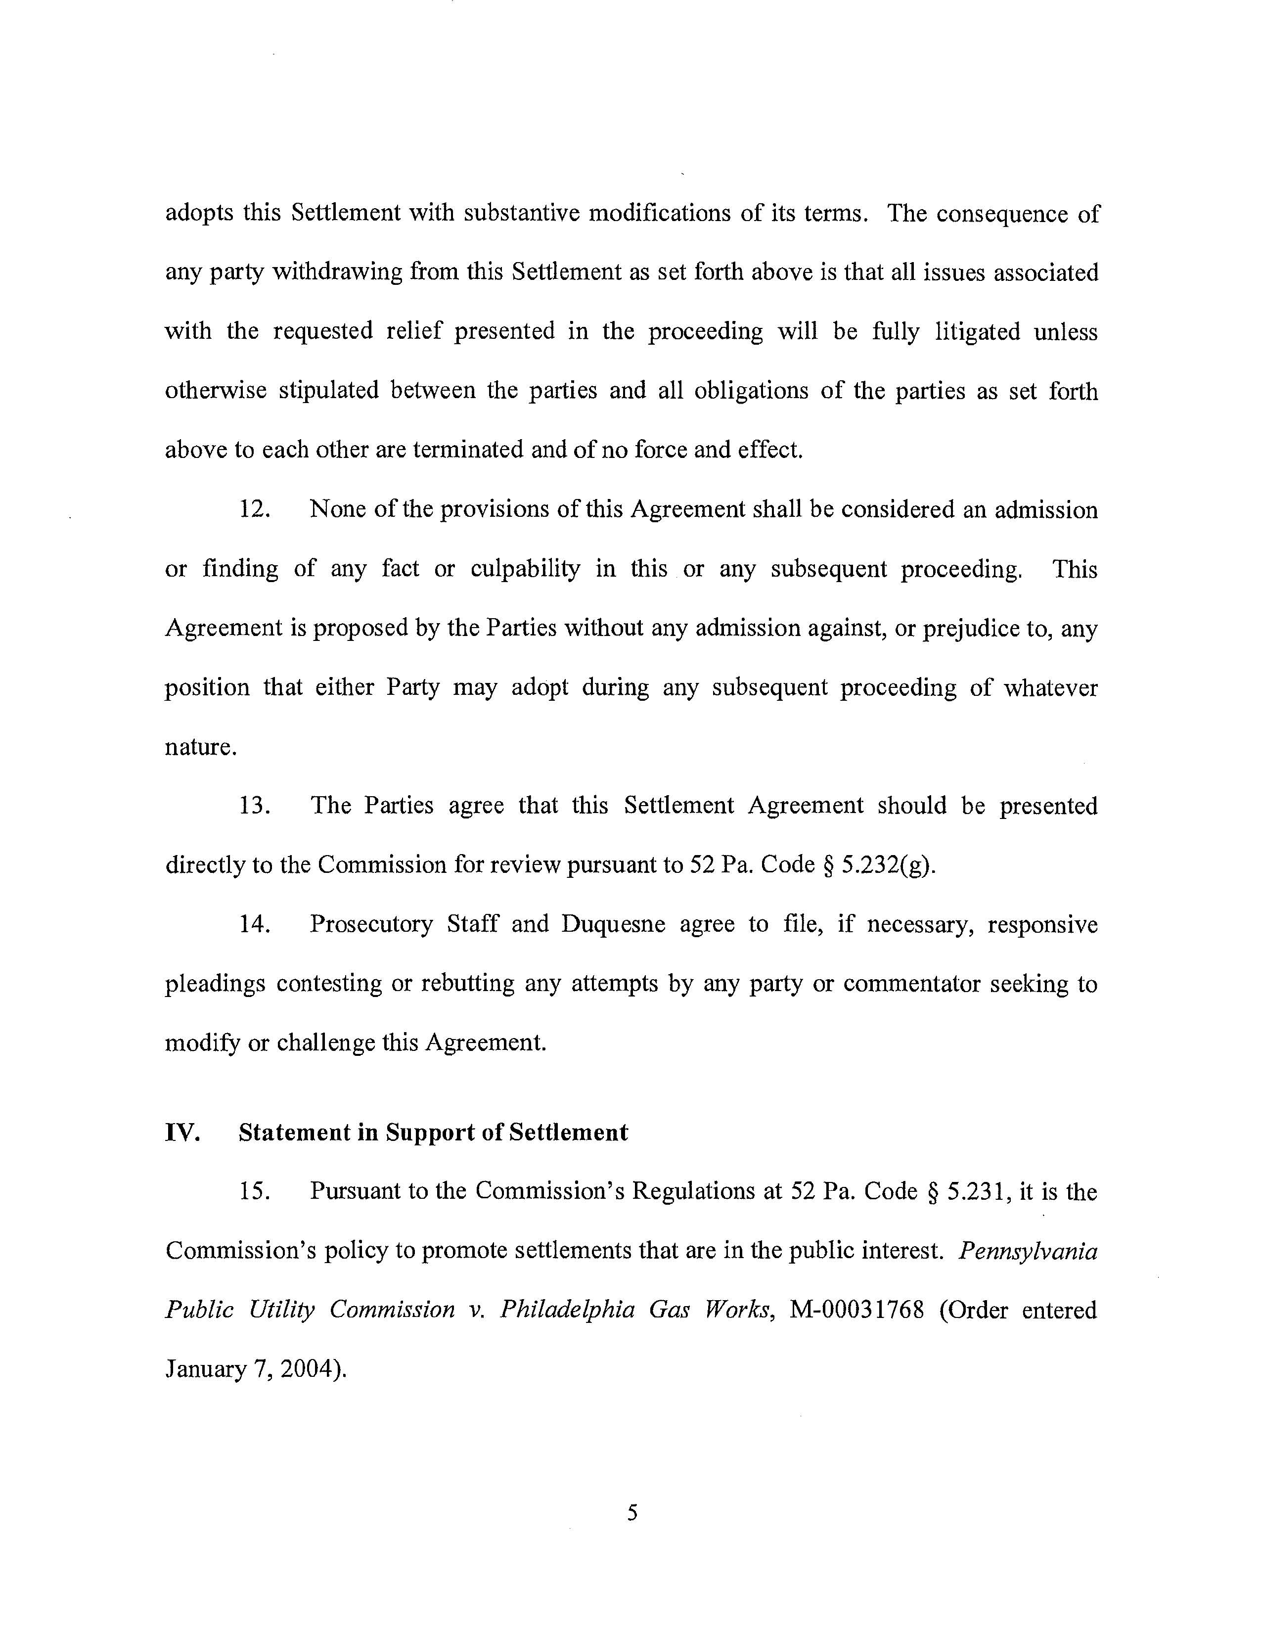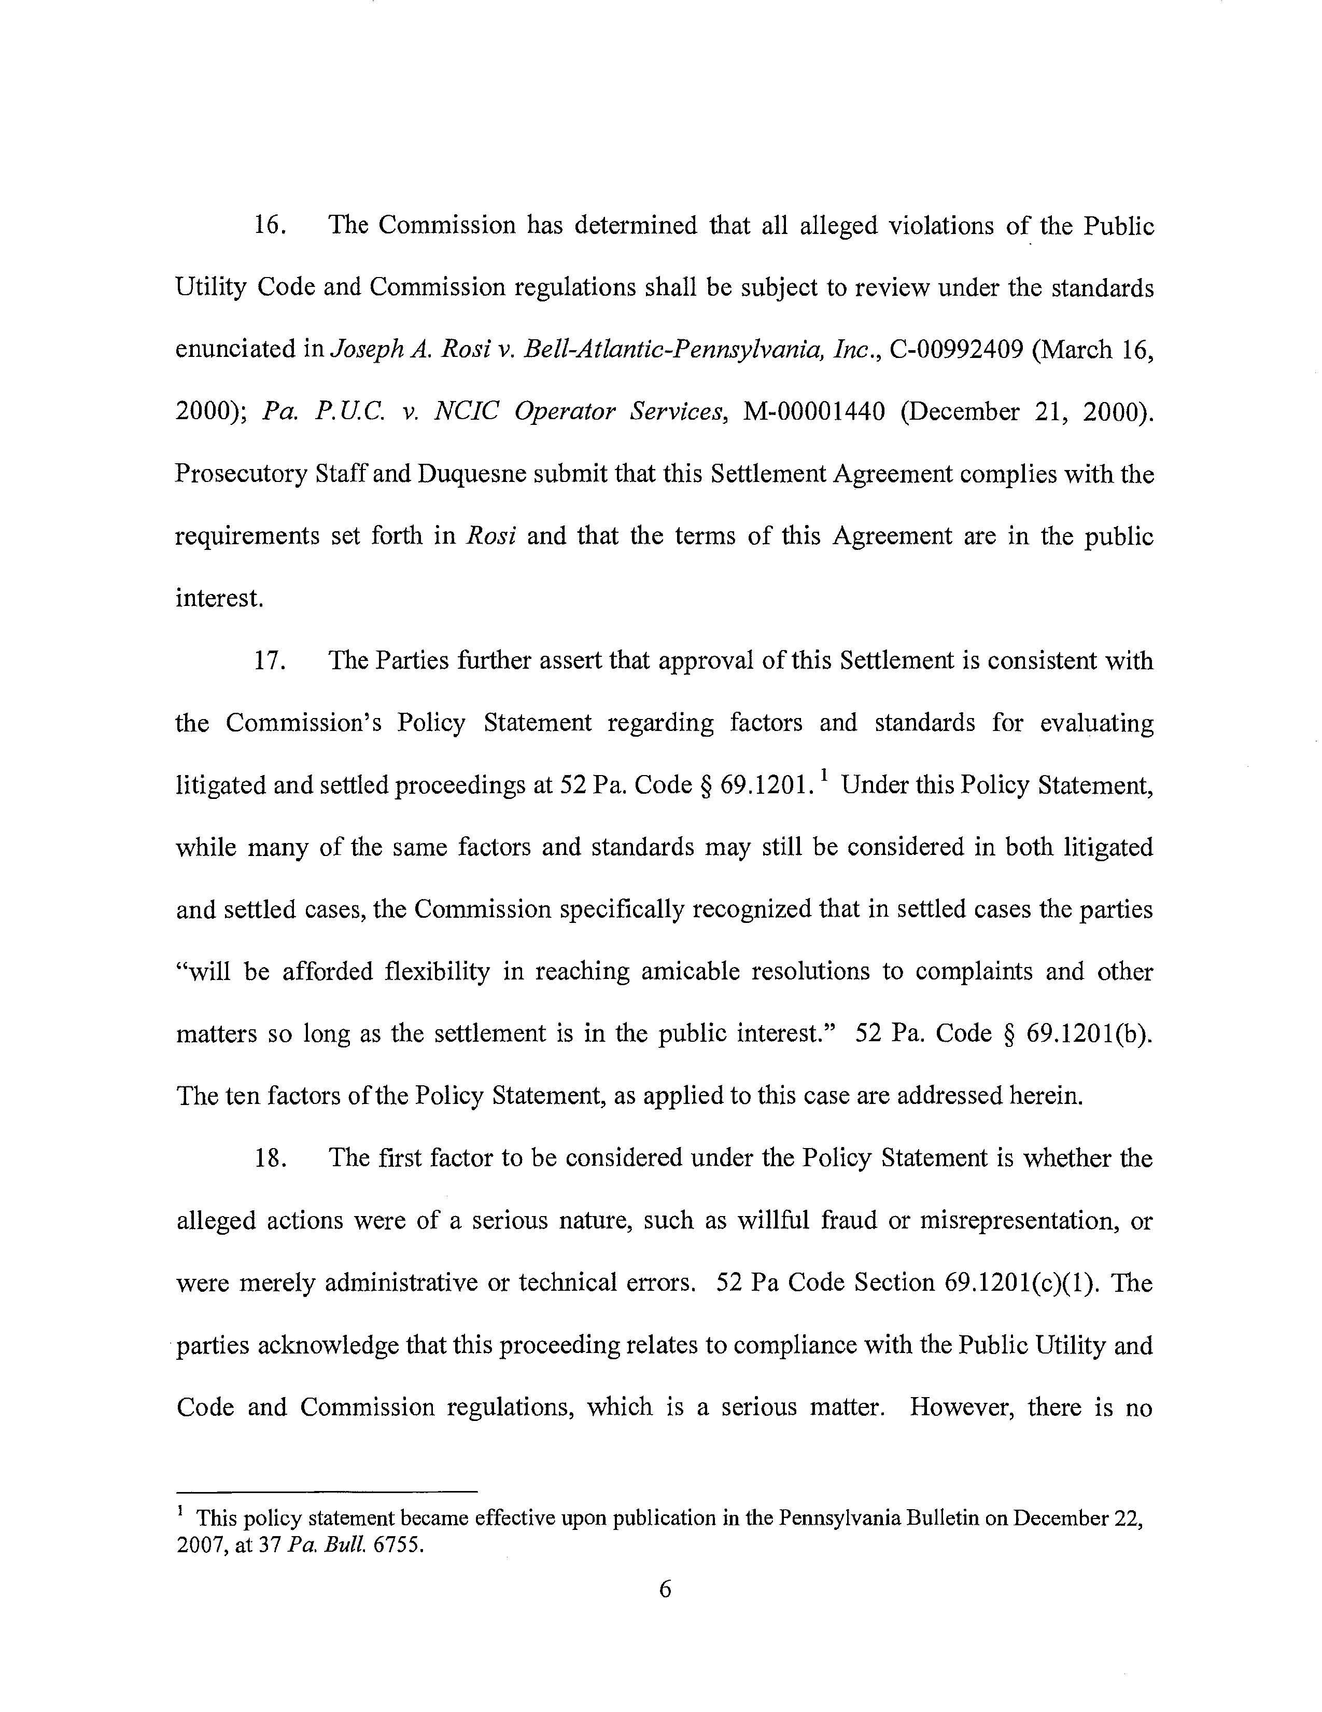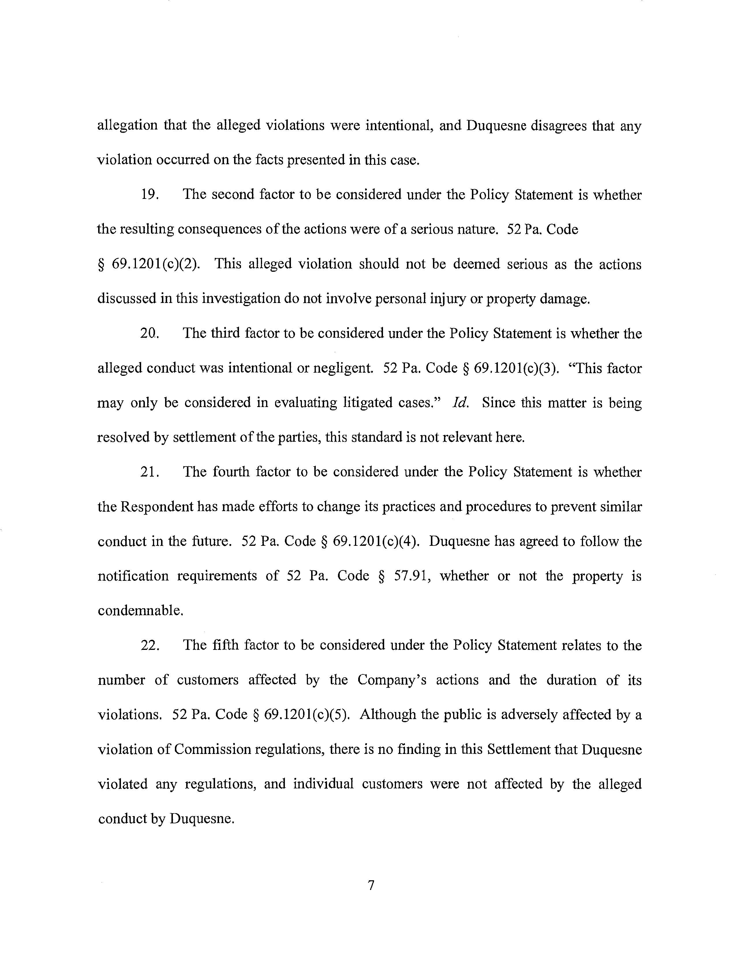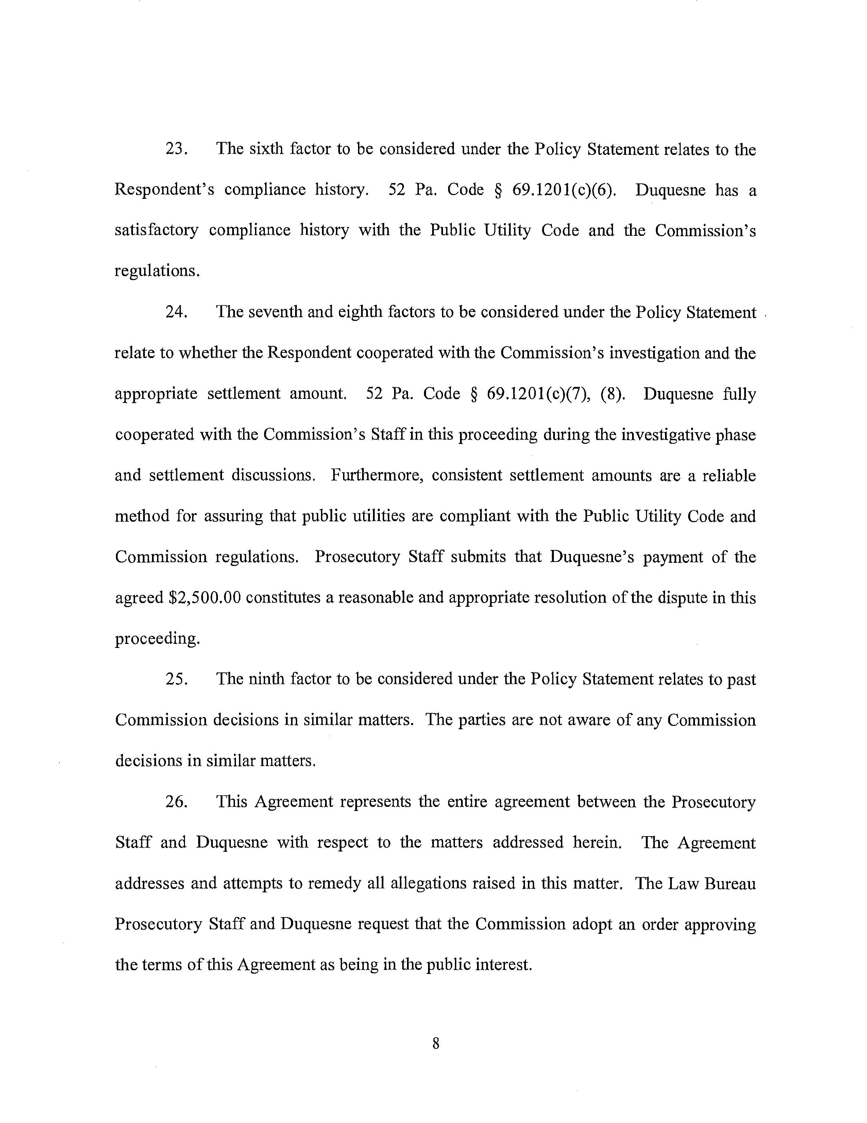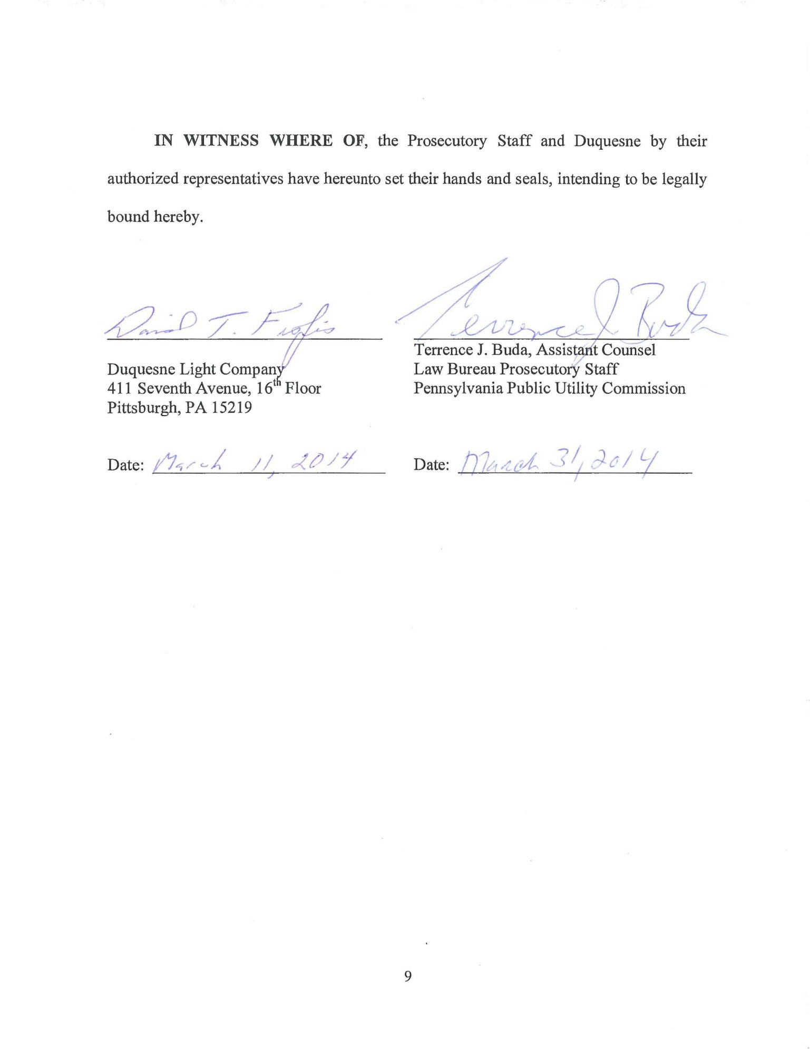

In its Report, LBPS provides an historical summary of actions and transactions affecting the parcel of real property at issue in this proceeding located at 143 Jarod Street, Coraopolis, Moon Township, Allegheny County (Property). Report at 1, 9. The Report also summarizes the additional allegations against Duquesne and the positions of the Parties.
Duquesne was apparently precluded from exercising its power of eminent domain to condemn the Property due to the proximity of the new transmission line to the dwelling on the Property. Report at 3 (citing 15 Pa. C.S. § 1511(b)(1)(i)).
Section 1102(a)(3) requires, in part, that a public utility obtain a Commission-approved certificate of public convenience before acquiring or transferring any tangible or intangible property “used or useful” in the public service. 66 Pa. C.S. § 1102(a)(3).
According to LBPS, a “straw purchase” involves an “individual who is not intended to have a genuine beneficial interest in a property to whom such property is nevertheless conveyed, in order to facilitate the eventual conveyance to another party. In many cases and situations, e.g., car purchase, firearms, mortgages, a straw purchase is illegal per se.” Report at 12 (emphasis in original).
It is not clear from the Report whether the “Chadwick Street” property includes or relates to the right-of-way the Company obtained in Sewickley Borough.
The terms are set forth in greater detail in the Settlement at 2-5.

