BEFORE THE
PENNSYLVANIA PUBLIC UTILITY COMMISSION

Petition of Peoples Natural Gas Company LLC ‒ : P-2013-2342745
Equitable Division for Approval of its Long Term :
Infrastructure Improvement Plan :

Petition of Peoples Natural Gas Company LLC ‒ :
Equitable Division for Approval of a : P-2013-2342745
Distribution System Improvement Charge :

Office of Consumer Advocate :
:
v. : C-2013-2348777
:
Peoples Natural Gas Company LLC ‒ :
Equitable Division :

SECOND INTERIM ORDER CLOSING THE RECORDS

AND NOW, the hearing in this matter having been held on December 18, 2014, and briefs having been filed, and no further hearings in this matter are to be scheduled or held.

THEREFORE,

IT IS ORDERED:

- That the records at Docket Nos. P-2013-2342745 and C-2013-2348777 shall be closed.

2. That the Recommended Decision in this matter shall be prepared and issued.

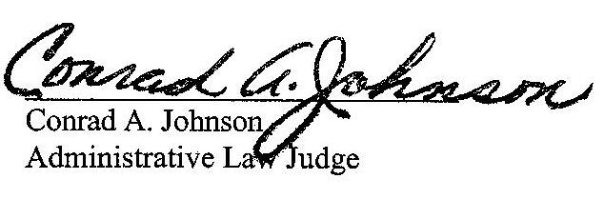
Dated: June 19, 2014

P-2013-2342745 – PETITION OF PEOPLES NATURAL GAS COMPANY LLC – EQUITABLE DIVISION FOR APPROVAL OF ITS LONG-TERM INFRASTRUCTURE IMPROVEMENT PLAN
P-2013-2342745 – PETITION OF PEOPLES NATURAL GAS COMPANY LLC — EQUITABLE DIVISION FOR APPROVAL OF A DISTRIBUTION SYSTEM IMPROVEMENT CHARGE
C-2013-2348777 – OFFICE OF CONSUMER ADVOCATE v. PEOPLES NATURAL GAS COMPANY LLC — EQUITABLE DIVISION

(Revised January 22, 2014)

thomas t niesen esquire
charles E thomas jr esquire
thomas long niesen & kennard
212 locust street SUITE 500
po box 9500
harrisburg PA 17108-9500
(717) 255-7600
tniesen@thomaslonglaw.com
cthomasjr@thomaslonglaw.com

DAVID W GRAY ESQUIRE
GENERAL COUNSEL
PEOPLES NATURAL GAS COMPANY LLC —
EQUITABLE DIVISION
225 NORTH SHORE DRIVE
PITTSBURGH PA 15212-5861
(412) 395-3634
dgray@equitablegas.com

CARRIE B WRIGHT ESQUIRE
PA PUBLIC UTILITY COMMISSION
BUREAU OF INVESTIGATION &
ENFORCEMENT
PO BOX 3265
HARRISBURG PA 17105-3265
(717) 783-6156
cawright@pa.gov

ERIN L GANNON ESQUIRE
DARRYL A LAWRENCE ESQUIRE
AMY HIRAKIS ESQUIRE
OFFICE OF CONSUMER ADVOCATE
555 WALNUT STREET
5TH FLOOR FORUM PLACE
HARRISBURG PA 17101-1923
(717) 783-5048
egannon@paoca.org
dlawrence@paoca.org
ahirakis@paoca.org

ELIZABETH ROSE TRISCARI ESQUIRE
OFFICE OF SMALL BUSINESS ADVOCATE
SUITE 1102
300 NORTH SECOND STREET
HARRISBURG PA 17101
(717) 783-2525
etriscari@pa.gov

KEVIN J MOODY ESQUIRE
GENERAL COUNSEL
PA INDEPENDENT OIL & GAS ASSOCIATION
212 LOCUST STREET SUITE 300
HARRISBURG PA 17101-1510
(717) 234-8525, Ext 113
kevin@pioga.org

