**PENNSYLVANIA PUBLIC UTILITY COMMISSION**

###### Public Meeting held July 24, 2014

Docket Number: M-2014-2431029

**BUREAU OF TECHNICAL UTILITY SERVICES**

**REPORT ON THE QUARTERLY EARNINGS**

**OF JURISDICTIONAL UTILITIES**

**FOR THE PERIOD ENDED**

**March 31, 2014**

|  |
| --- |
| Robert F. Powelson, Chairman |
| John F. Coleman, Jr., Vice Chairman |
| James H. Cawley |
| Pamela A. Witmer  Gladys M. Brown |
|  | |

#### TABLE OF CONTENTS

**Page No.**

**Introduction** ..................................................................................................... 5

Duquesne Light Company and Columbia Gas of Pennsylvania, Inc. had a pending rate filing at Docket Nos. R-2013-2372129 and R-2014-2406274 respectively, and filed a letter with the Secretary in place of a report in accordance with 52 Pa. Code § 71.4.

**Attachment A – Summary of Equity Returns**……………………………… 6

**Attachment B – Summary of Returns** 10

This chart depicts the overall and equity returns (actual and adjusted) for the filing utilities for the current quarter. The last authorized equity return and the year authorized is also shown.

**Attachment C – Allowed Rates of Return on Common Equity** 13

This is a historical chart that shows the most recent fully litigated rate cases for select companies in electric, gas, and water. A docket number followed by their final return on equity and year is also given.

**Attachment D – Market Based Returns on Equity – Electric** 14

The market indicated common equity cost rate range consists of data used from the electric barometer groups and is based on a series of calculations to average the DCF methods. Also indicates Distribution System Improvement Charge Return.

**Attachment D – Electric Barometer Group Calculation of a Current and 52 Week Average Dividend Yield** 15

Barometer water companies are used to calculate a current DCF in the first chart. The second chart demonstrates the companies 52 week average DCF. A final average of the two calculations is also shown at the bottom.

**Attachment D – Development of a Representative Dividend Growth Rate**…………………………………………………... 16

Multiple sources of the Barometer water companies projected 5 year Earnings Per Share are used to calculate the Group Average Dividend Growth Estimate.

**Attachment D – Common Equity Ratios of Electric Barometer Companies** 17

The Common Equity Ratios of Electric Utility Barometer Companies table depicts each company’s common equity ratio. The range of reasonable equity ratios consists of the lowest and highest common equity ratio in the quarter for the barometer group companies.

**Attachment D – Capital Structure and Cost of Debt and Preferred Stock** 18

The Capital Structure and Cost of Debt and Preferred Stock table is taken from the Schedule E and Schedule F of each Pennsylvania electric company’s quarterly earnings report.

**Attachment E – Market Based Returns on Equity – Gas** 19

The market indicated common equity cost rate range consists of data used from the gas barometer groups and is based on a series of calculations to average the DCF methods. Also indicates Distribution System Improvement Charge Return.

**Attachment E – Gas Barometer Group Calculation of a Current and 52 Week Average Dividend Yield** 20

Barometer water companies are used to calculate a current DCF in the first chart. The second chart demonstrates the companies 52 week average DCF. A final average of the two calculations is also shown at the bottom.

**Attachment E – Development of a Representative Dividend Growth Rate**…………………………………………………... 21

Multiple sources of the Barometer water companies projected 5 year Earnings Per Share are used to calculate the Group Average Dividend Growth Estimate.

**Attachment F – Market Based Returns on Equity – Water** 22

The market indicated common equity cost rate range consists of data used from the water barometer groups and is based on a series of calculations to average the DCF methods. Also indicates Distribution System Improvement Charge Return.

**Attachment F – Water Barometer Group Calculation of a Current and 52 Week Average Dividend Yield** 23

Barometer water companies are used to calculate a current DCF in the first chart. The second chart demonstrates the companies 52 week average DCF. A final average of the two calculations is also shown at the bottom.

**Attachment F – Development of a Representative Dividend Growth Rate**…………………………………………………... 24

Multiple sources of the Barometer water companies projected 5 year Earnings Per Share are used to calculate the Group Average Dividend Growth Estimate.

**Introduction:**

On September 20, 1991, the Commission initiated a rulemaking at L-00910061 pertaining to earnings disclosures by the public utilities subject to its jurisdiction. At that docket, the Commission stated that the submission of accurate, reliable and complete earnings disclosure reports, at regular intervals, is essential to the fulfillment of the broad regulatory oversight responsibilities entrusted to the Commission by the Legislature in the Public Utility Code. The earnings disclosure regulations promulgated by the Commission were adopted October 1, 1992, and published January 23, 1993 at, 23 Pa.B 463. Based upon those regulations, codified at 52 Pa. Code, Chapter 71, a reporting format was developed and distributed to the jurisdictional fixed utilities of Pennsylvania.

All fixed utilities having jurisdictional revenues of $1,000,000 or more, for a calendar year, are required to file the report by March 31 of each year. Such reports are to be based upon the results of operations for the 12-month period ending December 31 of the prior year. Utilities having more than $10,000,000 in jurisdictional revenues are also required to file reports for the 12 months ending on March 31, June 30, and September 30 of each year. On November 30, 2004, however, the Pennsylvania General Assembly signed into law Act 183 concerning alternative telecommunications regulation and broadband deployment. As a result of Act 183, the reporting requirements for the PUC jurisdictional telecommunications companies of Pennsylvania have been streamlined at 3015 (e) of the Public Utility Code. A quarterly earnings report is not listed among those reports now required of PUC jurisdictional telecommunications utilities in Pennsylvania and, therefore, this report does not address telephone company earnings.

The reports have been filed for the period ended March 31, 2014.[1] The Finance Staff of the Bureau of Technical Utility Services has reviewed the reports and has prepared this summary report for public release. This Report sets forth the achieved return on equity for each company, the last allowed return for that utility, a market return as determined through the analysis of the barometer group data and the most recent returns allowed, per industry, by the Pennsylvania Public Utility Commission and by other regulatory bodies. Where a utility has not filed a report, the reasons for not filing are indicated.

Questions pertaining to the preparation and contents of this Report should be directed to Ms. Erin Laudenslager, Manager - Finance, Bureau of Technical Utility Services, at (717) 705-4364.

The equity return summaries that follow in Attachment A are, for each quarter;

ACTUAL

1. Based on actual results of operations

and

ADJUSTED

2. Based on company proposed pro forma and ratemaking adjustments

|  |  |  |  |  |  |  |  |  |  |  |  |  |  |  |  |  |  |  |  |  |
| --- | --- | --- | --- | --- | --- | --- | --- | --- | --- | --- | --- | --- | --- | --- | --- | --- | --- | --- | --- | --- |
|  |  | **ELECTRIC UTILITIES**  **EQUITY RETURNS BY QUARTER** | | | | | | | | | | | | | | | | | | |
|  |  |  |  |  |  |  |  |  |  | |  | |  |  |  |  |  |  |  |
|  |  |  |  |  |  |  |  |  |  | |  | |  |  |  |  |  |  |  |
| **QTR**  **END** | | **PECO** | | **PPL** | | **Duq** | | **W Penn** | | **PaPwr** | | | | **UGI** | | **Penelec** | | **MetEd** | |  | |
| ACT | ADJ | ACT | ADJ | ACT | ADJ | ACT | ADJ | | ACT | ADJ | | ACT | ADJ | ACT | ADJ | ACT | ADJ |
|  |  |  |  |  |  |  |  |  |  | |  |  | |  |  |  |  |  |  |
| 2008 | 4 | 10.39 | 8.82 | 9.06 | 8.75 | 10.52 | 10.34 | 4.20 | 4.25 | | 8.67 | 7.09 | | 8.63 | 8.65 | 15.07 | 14.25 | 9.20 | 8.50 |
| 2009 | 1 | 10.84 | 8.84 | 10.00 | 10.00 | 10.90 | 10.90 | 5.20 | 5.20 | | 10.02 | 8.76 | | 7.55 | 7.55 | 6.39 | 5.83 | 5.22 | 4.69 |
|  | 2 | 11.44 | 9.82 | 11.04 | 11.04 | 9.67 | 9.67 | 7.04 | 7.04 | | 11.84 | 10.64 | | 3.42 | 8.30 | 8.01 | 7.67 | 7.20 | 6.93 |
|  | 3 | 11.27 | 10.36 | 10.47 | 10.47 | 9.05 | 9.05 | 8.26 | 8.26 | | 10.17 | 8.49 | | 6.96 | 9.05 | 10.34 | 9.51 | 9.74 | 8.63 |
|  | 4 | 11.58 | 7.70 |  |  | 9.20 | 9.20 | 8.58 | 8.40 | | 10.24 | 8.93 | | 8.03 | 11.15 | 9.71 | 9.21 | 4.23 | 3.36 |
| 2010 | 1 |  |  |  |  | 7.48 | 7.48 | 6.69 | 6.69 | | 12.66 | 11.19 | | 10.17 | 11.70 | 10.43 | 9.96 | 4.71 | 3.77 |
|  | 2 |  |  |  |  |  |  | 6.41 | 6.41 | | 12.28 | 10.19 | | 13.41 | 11.89 | 8.04 | 6.97 | 5.89 | 4.47 |
|  | 3 |  |  |  |  |  |  | 6.63 | 6.63 | | 12.19 | 10.23 | | 12.46 | 11.97 | 8.37 | 7.32 | 8.24 | 6.83 |
|  | 4 | 14.35 | 9.61 | 7.91 | 6.98 |  |  | 4.78 | 4.80 | | 6.88 | 4.69 | | 12.95 | 11.55 | 9.11 | 8.10 | 6.12 | 4.86 |
| 2011 | 1 | 11.74 | 11.34 | 8.31 | 8.31 |  |  | 8.43 | 6.80 | | 10.90 | 8.55 | | 13.46 | 13.47 | 9.57 | 8.62 | 10.56 | 9.21 |
|  | 2 | 12.25 | 11.03 | 9.41 | 9.41 | 10.86 | 10.39 | 10.05 | 8.40 | | 7.41 | 5.81 | | 14.11 | 12.94 | 6.51 | 6.38 | 7.68 | 6.43 |
|  | 3 | 10.35 | 11.07 | 8.89 | 8.89 | 10.05 | 9.58 | 12.95 | 11.21 | | 11.67 | 10.05 | | 14.84 | 12.93 | 8.73 | 8.18 | 9.90 | 7.50 |
|  | 4 | 13.41 | 11.38 |  |  | 10.21 | 9.97 | 13.33 | 11.58 | | 5.91 | 7.60 | | 14.60 | 9.79 | 6.45 | 8.43 | 4.24 | 5.23 |
| 2012 | 1 | 12.89 | 11.26 |  |  | 10.95 | 10.71 | 11.66 | 13.16 | | 5.78 | 7.02 | | 15.04 | 8.42 | 5.76 | 7.54 | 3.90 | 4.64 |
|  | 2 | 12.63 | 12.01 |  |  | 10.81 | 10.42 | 10.61 | 9.15 | | 8.95 | 8.95 | | 14.61 | 8.53 | 6.48 | 8.08 | 3.44 | 4.01 |
|  | 3 | 13.14 | 12.66 |  |  | 10.33 | 9.92 | 10.63 | 10.45 | | 9.69 | 9.54 | | 15.85 | 9.48 | 7.34 | 8.58 | 5.72 | 6.28 |
|  | 4 | 11.55 | 11.56 | 6.02 | 4.88 | 10.27 | 9.24 | 9.54 | 9.54 | | 8.41 | 8.27 | | 14.60 | 8.98 | 5.41 | 7.74 | 5.39 | 6.81 |
| 2013 | 1 | 11.92 | 11.27 | 7.56 | 6.24 | 10.12 | 9.74 | 9.23 | 9.23 | | 8.89 | 8.74 | | 12.77 | 9.84 | 5.30 | 7.67 | 5.01 | 6.47 |
|  | 2 | 11.40 | 10.74 | 7.80 | 7.37 |  |  | 12.34 | 12.34 | | 8.85 | 8.70 | | 11.53 | 10.49 | 5.86 | 8.21 | 5.36 | 6.79 |
|  | 3 | 11.09 | 10.96 | 8.67 | 8.38 |  |  | 9.13 | 9.13 | | 8.49 | 8.34 | | 10.74 | 10.65 | -0.77 | 2.07 | -12.43 | -10.43 |
|  | 4 | 11.97 | 10.52 | 10.01 | 9.79 |  |  | 13.73 | 13.73 | | 14.49 | 14.30 | | 14.25 | 11.99 | 4.85 | 2.99 | -6.06 | -7.87 |
| 2014 | 1 | 9.97 | 10.34 | 10.02 | 10.04 |  |  | 11.58 | 9.45 | | 15.28 | 15.04 | | 13.36 | 10.25 | 5.17 | 3.34 | -6.40 | -8.13 |
|  |  |  |  |  |  |  |  |  |  | |  |  | |  |  |  |  |  |  |

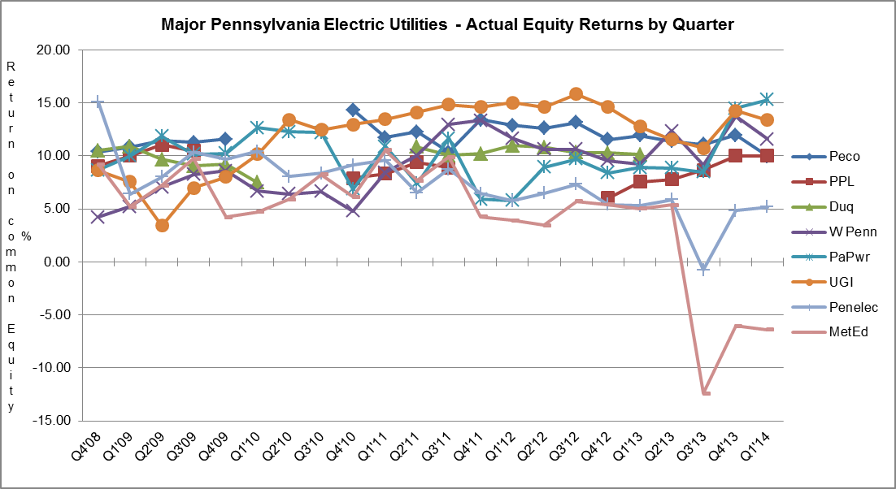

|  |  |  |  |  |  |  |  |  |  |  |  |  |  |  |  |  |  |  |
| --- | --- | --- | --- | --- | --- | --- | --- | --- | --- | --- | --- | --- | --- | --- | --- | --- | --- | --- |
|  |  | **GAS UTILITIES**  **EQUITY RETURNS BY QUARTER** | | | | | | | | | | | | | | | | |
| **QTR** |  | | **Columbia** | | **Peoples** | | **PECO** | | **UGI** | | **Equitable** | | **NFG** | | **UGI Penn** | | **Peoples TWP** | |
| **END** |  | | ACT | ADJ | ACT | ADJ | ACT | ADJ | ACT | ADJ | ACT | ADJ | ACT | ADJ | ACT | ADJ | ACT | ADJ |
|  |  | |  |  |  |  |  |  |  |  |  |  |  |  |  |  |  |  |
|  | 4 | | 5.52 | 10.71 | 18.96 | 9.00 | 2.48 | 2.43 | 12.62 | 11.01 |  |  | 16.42 | 11.22 |  |  | 4.94 | 3.84 |
| 2009 | 1 | | 9.85 | 11.05 | 16.74 | 8.14 | 5.82 | 9.06 | 13.92 | 9.88 | 5.89 | 9.51 | 15.64 | 9.79 | - | - | 4.98 | 3.27 |
|  | 2 | | 11.45 | 10.61 | 16.51 | 9.72 | 7.62 | 9.64 | 13.26 | 10.50 | 7.21 | 9.73 | 14.35 | 8.79 |  |  | 4.30 | 2.96 |
|  | 3 | | 10.97 | 9.17 | 20.06 | 7.84 | 8.95 | 10.59 | 6.96 | 9.05 | 8.40 | 10.13 | 14.74 | 12.48 | 2.21 | 8.31 | 4.97 | 3.15 |
|  | 4 | |  |  | 14.80 | 6.47 | 10.66 | 9.28 | 14.58 | 11.41 | 9.84 | 9.86 | 14.74 | 12.48 | 4.11 | 8.58 | 3.75 | 3.65 |
| 2010 | 1 | |  |  |  |  |  |  | 15.91 | 11.69 | 10.31 | 9.18 | 18.80 | 10.46 | 7.84 | 8.77 |  |  |
|  | 2 | |  |  | 9.65 | 5.25 |  |  | 15.97 | 11.48 | 9.47 | 8.99 | 19.13 | 10.33 | 8.86 | 7.95 |  |  |
|  | 3 | |  |  |  |  |  |  | 14.84 | 11.79 | 8.87 | 8.56 | 18.19 | 10.99 | 8.62 | 9.03 |  |  |
|  | 4 | | 12.50 | 7.67 |  |  | 10.21 | 9.94 | 16.52 | 11.88 | 8.78 | 8.67 | 18.97 | 11.29 | 9.57 | 10.12 | 3.27 | 9.57 |
| 2011 | 1 | |  |  |  |  | 11.74 | 11.34 | 19.61 | 13.11 | 9.48 | 9.78 | 19.87 | 12.11 | 13.08 | 12.17 | 6.52 | 9.06 |
|  | 2 | |  |  |  |  | 11.97 | 10.79 | 19.67 | 13.92 | 10.81 | 10.71 | 20.83 | 12.97 | 14.08 | 12.65 | 6.10 | 6.94 |
|  | 3 | |  |  | 5.67 | 8.47 | 12.56 | 11.15 | 18.24 | 11.98 | 10.40 | 9.93 | 21.16 | 13.05 | 14.32 | 11.48 | 5.78 | 6.67 |
|  | 4 | |  |  |  |  | 11.69 | 12.06 | 16.55 | 9.18 | 7.99 | 8.89 | 19.62 | 12.34 | 14.01 | 9.35 | 6.75 | 5.56 |
| 2012 | 1 | | 8.65 | 11.24 |  |  | 8.98 | 12.09 | 15.71 | 8.95 | 2.29 | 8.05 | 15.76 | 10.51 | 13.22 | 9.63 | 5.24 | 3.39 |
|  | 2 | | 9.00 | 10.17 |  |  | 8.72 | 12.03 | 13.60 | 9.90 | 5.51 | 7.51 | 14.10 | 10.06 | 13.63 | 10.40 | 4.57 | 6.43 |
|  | 3 | | 9.27 | 8.88 | 6.21 | 9.35 | 9.98 | 13.48 | 13.79 | 10.05 | 5.84 | 7.79 | 13.88 | 10.39 | 13.16 | 10.66 | 7.02 | 7.41 |
|  | 4 | |  |  | 11.24 | 9.57 | 12.42 | 15.10 | 13.68 | 9.44 | 7.27 | 8.05 | 15.11 | 10.17 | 13.31 | 10.63 | 5.05 | 6.94 |
| 2013 | 1 | |  |  | 12.49 | 9.89 | 14.63 | 15.13 | 14.65 | 10.27 | 12.42 | 8.40 | 19.33 | 10.25 | 13.28 | 10.58 |  |  |
|  | 2 | | 10.85 | 7.15 | 16.59 | 8.35 | 14.43 | 14.40 | 13.02 | 10.21 | 10.40 | 8.92 | 20.18 | 10.25 | 10.98 | 10.27 |  |  |
|  | 3 | | 9.36 | 9.86 | 17.39 | 8.72 | 14.14 | 14.01 | 12.60 | 9.38 | 9.84 | 9.48 | 19.61 | 10.72 | 10.59 | 10.76 |  |  |
|  | 4 | | 10.60 | 10.78 | 16.33 | 10.02 | 14.35 | 13.97 | 16.08 | 9.20 | 10.52 | 9.76 | 20.51 | 10.07 | 13.41 | 10.49 | 7.21 | 12.23 |
| 2014 | 1 | |  |  | 14.68 | 9.94 | 15.23 | 13.52 | 16.81 | 8.35 | 12.00 | 8.73 | 23.11 | 9.78 | 16.67 | 10.06 | 12.19 | 11.87 |
|  |  | |  |  |  |  |  |  |  |  |  |  |  |  |  |  |  |  |

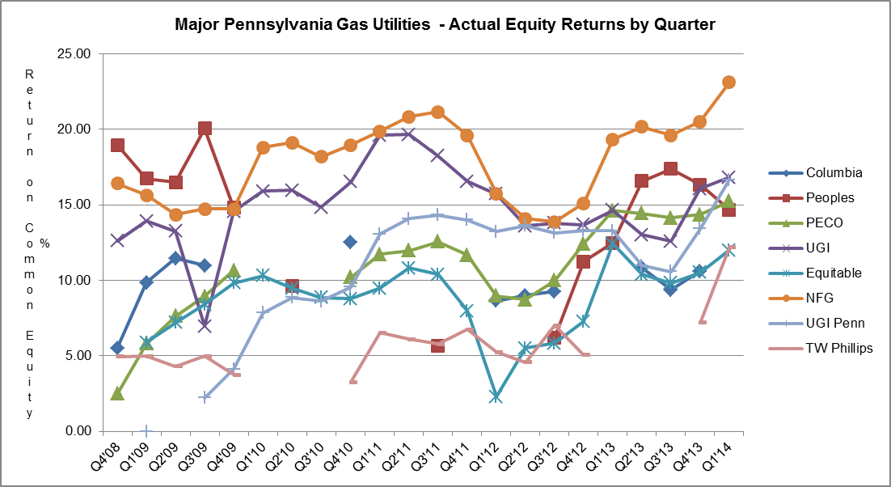

|  |  |  |  |  |  |  |  |  |  |  |  |
| --- | --- | --- | --- | --- | --- | --- | --- | --- | --- | --- | --- |
| **WATER UTILITIES** | | | | | | | | | | | |
| **EQUITY RETURNS BY QUARTER** | | | | | | | | | | | | | |
|  |  |  |  |  |  |  |  |  |  |
|  |  |  |  |  |  |  |  |  |  |
| **QTR** |  | **PAWC** | | **AQUA** | | **United** | | **York** | | **Superior** | | |
| **END** |  | ACT | ADJ | ACT | ADJ | ACT | ADJ | ACT | ADJ | ACT | ADJ | |
|  |  |  |  |  |  |  |  |  |  |  |  | |
| 2008 | 4 | 8.85 | 9.43 | 10.87 | 10.44 | 7.15 | 8.40 | 8.20 | 10.00 |  |  | |
| 2009 | 1 |  |  | 11.45 | 10.78 | 8.80 | 9.60 | 7.28 | 8.40 |  |  | |
|  | 2 |  |  | 11.69 | 10.71 | 9.20 | 9.30 | 6.50 | 7.71 |  |  | |
|  | 3 |  |  |  |  | 5.70 | 6.93 | 9.20 | 8.60 |  |  | |
|  | 4 |  |  |  |  | 5.66 | 5.84 | 8.80 | 9.00 |  |  | |
| 2010 | 1 | 8.72 | 8.10 |  |  | 5.74 | 6.57 | 8.90 | 8.70 |  |  | |
|  | 2 | 9.30 | 9.30 |  |  | 6.59 | 7.54 |  |  |  |  | |
|  | 3 | 9.58 | 9.58 | 10.19 | 10.35 | 7.15 | 8.34 |  |  |  |  | |
|  | 4 | 9.18 | 8.52 | 10.10 | 8.94 | 4.66 | 8.69 | 10.4 | 11.2 |  |  | |
| 2011 | 1 |  |  | 10.68 | 8.32 | 5.02 | 8.81 | 10.8 | 11.1 |  |  | |
|  | 2 |  |  | 10.92 | 7.93 | 4.72 | 8.61 | 11.1 | 10.2 |  |  | |
|  | 3 |  |  |  |  | 3.92 | 7.69 | 10.9 | 10.2 |  |  | |
|  | 4 |  |  |  |  | 7.69 | 8.00 | 10.8 | 10.0 |  |  | |
| 2012 | 1 | 8.98 | 8.98 |  |  | 7.38 | 7.84 | 10.7 | 9.5 |  |  | |
|  | 2 | 9.06 | 9.06 |  |  | 7.30 | 7.65 | 10.4 | 9.4 |  |  | |
|  | 3 | 9.17 | 9.17 | 9.50 | 7.77 | 7.96 | 8.38 | 10.5 | 9.1 |  |  | |
|  | 4 | 9.54 | 9.04 | 12.41 | 12.56 | 8.33 | 8.49 | 10.4 | 9.1 |  |  | |
| 2013 | 1 |  |  | 13.24 | 11.96 | 8.53 | 8.71 |  |  |  |  | |
|  | 2 |  |  | 14.26 | 12.52 | 8.99 | 9.15 |  |  | 8.57 | 7.85 | |
|  | 3 |  |  | 15.49 | 12.21 | 8.83 | 9.01 |  |  | 7.46 | 6.85 | |
|  | 4 |  |  | 13.77 | 11.97 | 8.43 | 9.05 | 10.2 | 10.8 | 10.71 | 10.01 | |
| 2014 | 1 | 10.52 | 9.98 | 13.29 | 11.56 | 8.45 | 9.02 | 10.2 | 10.2 |  |  | |
|  |  |  |  |  |  |  |  |  |  |
|  |  |  |  |  |  |  |  |  |  |

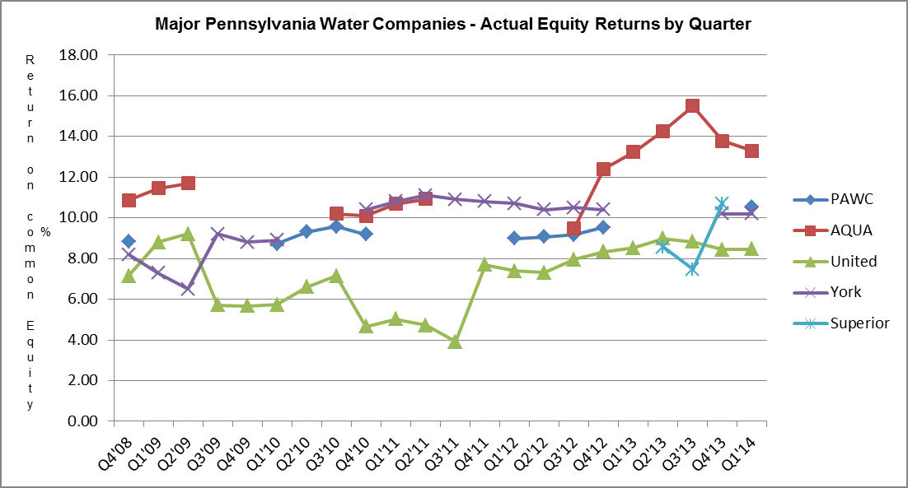

Attachment B includes:

A. Overall Returns on rate base

1. Actual

2. Company proposed pro forma and ratemaking adjustments

and

B. Equity Returns

1. Actual

2. Company proposed pro forma and ratemaking adjustments

|  |  |  |  |  |  |  |  |  |  |  |
| --- | --- | --- | --- | --- | --- | --- | --- | --- | --- | --- |
| Attachment B  1 of 2  Summary of Returns | | | | | | | | | | |
| for the Year Ended March 31, 2014 | | | | | | | | | | |
|  | **OVERALL** | **RETURN** |  | **EQUITY** | **RETURN** | ROE | YEAR |  |  |  |
| COMPANY NAME | ACTUAL | ADJ |  | ACTUAL | ADJ | AUTH | AUTH |  |  |  |
| **ELECTRIC** |  |  |  |  |  |  |  |  |  |  |
| **$10,000,000 Revenues** |  |  |  |  |  |  |  |  |  |  |
| PECO Energy | 7.68 | 7.90 |  | 9.97 | 10.34 | Settled | 2010 |  |  |  |
| PPL Electric Utilities Corp. | 7.72 | 7.73 |  | 10.02 | 10.04 | 10.40 | 2012 |  |  |  |
| Duquesne Light Company* |  |  |  |  |  | Settled | 2011 |  |  |  |
| West Penn Power Company | 8.62 | 7.48 |  | 11.58 | 9.45 | 11.50 | 1995 |  |  |  |
| Pennsylvania Power Company | 10.74 | 10.61 |  | 15.28 | 15.04 | 12.91 | 1988 |  |  |  |
| UGI Utilities, Inc. | 10.42 | 8.23 |  | 13.36 | 10.25 | 10.58 | 1996 |  |  |  |
| Pennsylvania Electric Company | 6.20 | 5.26 |  | 5.17 | 3.34 | 10.10 | 2007 |  |  |  |
| Metropolitan Edison Company | -0.33 | -1.21 |  | -6.40 | -8.13 | 10.10 | 2007 |  |  |  |
| **GAS** |  |  |  |  |  |  |  |  |  |  |
| **$10,000,000 Revenues** |  |  |  |  |  |  |  |  |  |  |
| Columbia Gas of PA, Inc.* |  |  |  |  |  | Settled | 2013 |  |  |  |
| Peoples Natl Gas LLC | 10.41 | 7.37 |  | 14.68 | 9.94 | Settled | 2012 |  |  |  |
| PECO Energy | 10.70 | 9.74 |  | 15.23 | 13.52 | Settled | 2010 |  |  |  |
| UGI Utilities, Inc. | 12.47 | 7.16 |  | 16.81 | 8.35 | Settled | 1995 |  |  |  |
| Equitable Gas Company | 8.66 | 6.69 |  | 12.00 | 8.73 | Settled | 2008 |  |  |  |
| National Fuel Gas Distribution Co. | 14.50 | 7.41 |  | 23.11 | 9.78 | Settled | 2006 |  |  |  |
| UGI Penn Natural Gas, Inc. | 11.69 | 8.12 |  | 16.67 | 10.06 | Settled | 2009 |  |  |  |
| Peoples TWP, LLC | 8.79 | 8.58 |  | 12.19 | 11.87 | Settled | 2013 |  |  |  |
| UGI Central Penn Gas, Inc. | 13.68 | 9.76 |  | 19.46 | 12.97 | 10.40 | 2009 |  |  |  |
| **WATER** |  |  |  |  |  |  |  |  |  |  |
| **$10,000,000 Revenues** |  |  |  |  |  |  |  |  |  |  |
| PA American Water Company | 8.19 | 7.92 |  | 10.52 | 9.98 | Settled | 2013 |  |  |  |
| AQUA Pennsylvania | 9.70 | 8.75 |  | 13.29 | 11.56 | Settled | 2012 |  |  |  |
| York Water Company | 8.6 | 8.6 |  | 10.2 | 10.2 | Settled | 2014 |  |  |  |
| United Water Penna. Inc. | 7.35 | 7.66 |  | 8.45 | 9.02 | Settled | 2009 |  |  |  |
| Superior Water Company |  |  |  |  |  | Settled | 2011 |  |  |  |
|  |  |  |  |  |  |  |  |  |  |  |
|  |  |  |  |  |  |  |  |  |  |  |
|  |  |  |  |  |  |  |  |  |  |  |
|  |  |  |  |  |  |  |  |  |  |  |
|  |  |  |  |  |  |  |  |  |  |  |
|  |  |  |  |  |  |  |  |  |  |  |
|  |  |  |  |  |  |  |  |  |  |  |
|  |  |  |  |  |  |  |  |  |  |  |
|  |  |  |  |  |  |  |  |  |  |  |
|  |  |  |  |  |  |  |  |  |  |  |
|  |  |  |  |  |  |  |  |  |  |  |
|  |  |  |  |  |  |  |  |  |  |  |
|  |  |  |  |  |  |  |  |  |  |  |
|  |  |  |  |  |  |  |  |  |  |  |

* Duquesne Light Company and Columbia Gas of Pennsylvania, Inc. had a pending rate filing at Docket Nos. R-2013-2372129 and R-2014-2406274 respectively, and filed a letter with the Secretary in place of a report in accordance with 52 Pa. Code § 71.4.

Attachment B

2 of 2

UGI Utilities, Inc.-Gas

Return on equity adjusted from 16.81% to 8.35% based on the following company adjustments to actual results of operations.

1. $ 21,942,000 Rate Base Inventory Increase
2. $ 135,449,000 Rate Base Plant in Service Increase
3. $ (27,711,000) Normalization of Operating Revenue Decrease
4. $ (17,804,000) Tax Expense Decrease

National Fuel Gas Distribution Corporation

Return on equity adjusted from 23.11% to 9.78% based on the following company adjustments to actual results of operations.

1. $ 31,724,000 Rate Base Plant Increase
2. $ 37,739,000 Rate Base Cash Working Capital Increase
3. $ (28,098,000) Operating Revenue Decrease
4. $ (11,417,000) Operating and Maintenance Expense Decrease

UGI Penn Natural Gas, Inc.

Return on equity adjusted from 16.67% to 10.06% based on the following company adjustments to actual results of operations.

1. $ 19,536,000 Rate Base Inventory Increase
2. $ 64,602,000 Rate Base Plant in Service Increase
3. $ (7,528,000) Operating Revenue Decrease
4. $ (5,186,000) Tax Expense Decrease

UGI Central Penn Gas, Inc.

Return on equity adjusted from 19.46% to 12.97% based on the following company adjustments to actual results of operations.

1. $ 5,172,000 Rate Base Plant Increase
2. $ 37,739,000 Rate Base Plant in Service Increase
3. $ 6,292,000 Rate Base Depreciation Decrease

Attachment C

**ALLOWED RATES OF RETURN ON COMMON EQUITY**

This is a historical chart that shows the most recent fully litigated rate cases for select companies in electric, gas, and water. A docket number followed by their final return on equity and year is also given.

**ELECTRIC** **Docket Number ROE (%) Year**

Recent PA PUC Allowed

PPL Electric Utilities Corp. R-2012-2290597 10.40 2012

PECO Energy Company R-2010-2161575 Settled 2010

West Penn Power Company R-00942986 11.50 1995

UGI - Electric R-00932862 10.58 1996

Pennsylvania Electric Company R-00061367 10.10 2007

Metropolitan Edison Company R-00061366 10.10 2007

Current Market Indicated ROE as calculated by the **7.17-10.07**

Bureau of Technical Utility Services.

**GAS**

Recent PA PUC Allowed

Columbia Gas of Pa. R-2012-2321748 Settled 2013

UGI Utilities, Inc. – Gas R-00953297 Settled 1995

Peoples Natural Gas Co. R-2012-2285985 Settled 2012

UGI Central Penn Gas R-2008-2079660 Settled 2008

PECO Energy R-2010-2161592 Settled 2010

Current Market Indicated ROE as calculated by the **7.76-9.10**

Bureau of Technical Utility Services.

**WATER**

Recent PA PUC Allowed

Aqua Pennsylvania R-2011-2267958 Settled 2012

Penna American Water Co. R-2013-2355276 Settled 2013

Current Market Indicated ROE as calculated by the **7.97-10.41**

Bureau of Technical Utility Services.

The market indicated common equity cost rate range consists of data used from the barometer groups and is based on a series of calculations to average the DCF methods.



Barometer electric companies are used to calculate a current DCF in the first chart. The second chart demonstrates the companies 52 week average DCF. A final average of the two calculations is also shown at the bottom.



Multiple sources of the Barometer companies projected 5 year Earnings Per Share are used to calculate the Group Average Dividend Growth Estimate.



The Common Equity Ratios of Electric Utility Barometer Companies table depicts each company’s quarterly common equity ratio. The range of Reasonable Equity Ratios consists of the lowest and highest common equity ratio for the barometer group companies.

Company

Consolidated Edison

Dominion Resources

PPL Corporation

Public Service Enterprise Group

PEPCO Holdings, Inc.

UIL Holdings

**Average**

**Range of Reasonable Equity Ratios**

50.50%

42.50%

55.50%

Common Equity Ratios of Electric Utility Barometer Groups (2)

2014 Common Equity Ratio (1)

51.00%

41.50%

(1) Source: Value Line Investment Survey July 3, 2014

(2) The common equity ratios reported by Value Line exclude short-term

debt and current maturities of long-term debt.

42.00%

**47.17%**

**41.50-55.50%**

The Capital Structure and Cost of Debt and Preferred Stock table shows the Schedule E and Schedule F of each company’s quarterly earnings report.



The market indicated common equity cost rate range consists of data used from the barometer groups and is based on a series of calculations to average the DCF methods.



Barometer gas companies are used to calculate a current DCF in the first chart. The second chart demonstrates the companies 52 week average DCF. A final average of the two calculations is also shown at the bottom.



Multiple sources of the Barometer companies projected 5 year Earnings Per Share are used to calculate the Group Average Dividend Growth Estimate.



The market indicated common equity cost rate range consists of data used from the barometer groups and is based on a series of calculations to average the DCF methods.



Barometer water companies are used to calculate a current DCF in the first chart. The second chart demonstrates the companies 52 week average DCF. A final average of the two calculations is also shown at the bottom.



Multiple sources of the Barometer companies projected 5 year Earnings Per Share are used to calculate the Group Average Dividend Growth Estimate.



1. Duquesne Light Company and Columbia Gas of Pennsylvania, Inc. had a pending rate filing at Docket Nos. R‑2013‑2372129 and R-2014-2406274 respectively, and filed a letter with the Secretary in place of a report in accordance with 52 Pa. Code § 71.4.