COMMONWEALTH OF PENNSYLVANIA
PENNSYLVANIA PUBLIC UTILITY COMMISSION
P O BOX 3265, HARRISBURG PA 17105-3265
Formal Complaint
Docket #: C-2015-2464230
Date Served: January 28, 2015

ANTHONY D. KANAGY, ESQUIRE
POST & SCHELL P.C.
17 NORTH 2ND STREET
12TH FLOOR
HARRISBURG, PA 17101-1601

RE: PA PUC vs NATIONAL FUEL GAS DISTRIBUTION CORPORATION
Rate Case Docket #: R-2015-2461373

Dear Mr. Kanagy:

A Formal Complaint has been filed against you in the above-captioned matter before the Pennsylvania Public Utility Commission by John Evans.

This true and correct copy of the complaint has been filed of record with the Pennsylvania Public Utility Commission. Both the Pennsylvania Public Utility Code, 66 Pa. C.S. and the Commission’s regulations at 52 Pa. Code Section 1.53, requires the Commission to serve on each party named in a Formal Complaint a copy of the complaint.

Within ten (10) days from the above date of service, you may either satisfy or answer this complaint in accordance with the provisions of 52 Pa Code, §5.61(d).

When filing your answer to the Formal Complaint, please reference the “Formal Complaint Docket Number” located in the upper-right hand corner of this Notice.

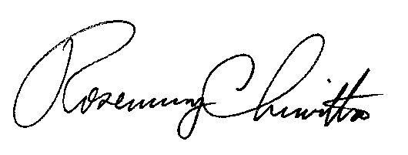
Very Truly Yours,

Rosemary Chiavetta
Secretary

RC: al

(SEAL)
Certified Mail
Return Receipt Requested

