COMMONWEALTH OF PENNSYLVANIA
PENNSYLVANIA PUBLIC UTILITY COMMISSION
P O BOX 3265, HARRISBURG PA 17105-3265
Formal Complaint
Docket #: C-2015-2468927
Date Served: February 25, 2015

D. TROY SELLARS, ESQUIRE
DANIEL P. ZAMBITO, ESQUIRE
COZEN O’CONNOR
305 NORTH FRONT STREET, SUITE 400
HARRISBURG, PA 17101

RE: PA PUC vs UNITED WATER PENNSYLVANIA, INC.
Rate Case Docket #: R-2015-2462723

Dear Sir or Madam:

A Formal Complaint has been filed against you in the above-captioned matter before the Pennsylvania Public Utility Commission by Amy Patton.

This true and correct copy of the complaint has been filed of record with the Pennsylvania Public Utility Commission. Both the Pennsylvania Public Utility Code, 66 Pa. C.S. and the Commission’s regulations at 52 Pa. Code Section 1.53, requires the Commission to serve on each party named in a Formal Complaint a copy of the complaint.

Within ten (10) days from the above date of service, you may either satisfy or answer this complaint in accordance with the provisions of 52 Pa Code, §5.61(d).

When filing your answer to the Formal Complaint, please reference the “Formal Complaint Docket Number” located in the upper-right hand corner of this Notice.

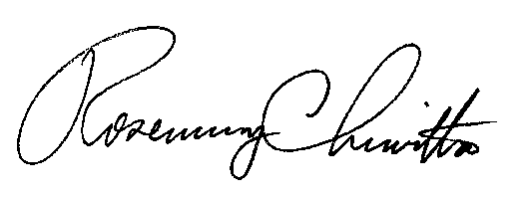
Very Truly Yours,

Rosemary Chiavetta
Secretary

RC: al

(SEAL)
Certified Mail
Return Receipt Requested

