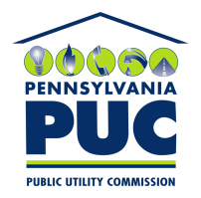 | COMMONWEALTH OF PENNSYLVANIA  PENNSYLVANIA PUBLIC UTILITY COMMISSION  P.O. BOX 3265, HARRISBURG, PA 17105-3265 | IN REPLY PLEASE REFER TO OUR FILE
Date Served: March 19, 2015

VIA CERTIFIED MAIL

WILLIAM A GRAY
VUONO & GRAY LLC
310 GRANT ST STE 2310
PITTSBURGH PA 15219

RE: Friendly Movers, LLC.
A-2015-2471558

Dear Mr. Gray:

Please know we are returning the enclosed check (No. 1398) because it is not signed. Please sign the check and return it to the above address so we are able to finish the processing of the application for motor common carrier of property.

Sincerely,

Rosemary Chiavetta
Secretary of the Commission

Enclosure

ane

