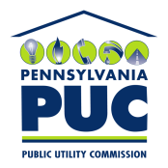 | COMMONWEALTH OF PENNSYLVANIA  PENNSYLVANIA PUBLIC UTILITY COMMISSION  P.O. BOX 3265, HARRISBURG, PA 17105-3265 | IN REPLY PLEASE REFER TO OUR FILE
March 26, 2015

PAUL J. SZYKMAN
UGI UTILITIES-ELECTRIC R-2015-2471674
2525 NORTH 12th ST.
SUITE 360
READING, PA 19612-2677

Re: State Tax Adjustment Surcharge
UGI Utilities, Inc.-Electric Division

Dear Mr. Szykman:

On March 10, 2015 your company filed a State Tax Adjustment Surcharge tariff in response to changes to Pennsylvania corporate tax rates. The Commission hereby accepts this tariff, and we are therefore allowing the tariff to go into effect by operation of law. However, this notification shall not preclude this Commission from investigating the financial affairs of your company and, in appropriate cases, ordering refunds or other remedies, which it deems proper.
Very truly yours,

Rosemary Chiavetta
Secretary

cc: Marissa Boyle, TUS

