BEFORE THE
PENNSYLVANIA PUBLIC UTILITY COMMISSION

Donald W. Smith, Jr. :
:
v. : F-2015-2490758
:
Philadelphia Gas Works :

INTERIM ORDER CONFIRMING THE GRANTING OF
COMPLAINANT’S MOTION FOR CONTINUANCE OF HEARING

By Notice dated August 25, 2015, the parties were informed that a hearing was scheduled before me for this proceeding on Wednesday, October 14, 2015, at 10:00 a.m. On October 13, 2015, Complainant Donald W. Smith, Jr. telephoned the Pittsburgh Office of Administrative Law Judge, requesting a continuance of the hearing. Complainant represented that several deaths had occurred in his family over the past week, and therefore, he needed a continuance of the hearing. He further represented that he had spoken with Attorney Laureto Farinas, counsel for Respondent Philadelphia Gas Works, who had no objection to the continuance request. Because of time constraints, on October 13, 2015, I directed my legal assistant to inform the parties that an interim order would be issued granting the continuance request. The within order confirms the granting of Complainant’s hearing continuance request.

Pursuant to 52 Pa.Code § 1.15(b), a request for a change of the scheduled hearing date shall be submitted by motion in writing, filed no later than five (5) days prior to the hearing with the Pennsylvania Public Utility Commission (Commission). The motion must state the facts upon which the request rests. Only for good cause shown will requests for continuance be considered (52 Pa. Code §1.15(b)).

Although Complainant’s October 13, 2015 telephone call to request a hearing continuance did not conform to the requirements of a formal motion under Section 1.15(b) of the
Commission’s regulations, waiver of this requirement was permitted. Under Section 1.2, 52 Pa.Code § 1.2, a presiding officer at any stage of an action or proceeding may waive a requirement of a rule when necessary or appropriate, if waiver does not adversely affect a substantive right of a party. Such were the circumstances in this case. Therefore, Complainant’s October 13, 2015 telephone call was treated as a motion.

I found that the motion stated good cause to warrant a hearing continuance: Complainant had experienced recent deaths in his family. Accordingly, a notice will be issued rescheduling the hearing for the next available date.

The parties are encouraged to talk with each other to resolve this matter or some portion thereof. It is the Commission’s policy to encourage settlements. 52 Pa.Code § 5.231.

THEREFORE,

IT IS ORDERED:

- That the October 13, 2015 granting of the hearing continuance requested by Complainant Donald W. Smith, Jr. in the matter of Donald W. Smith, Jr. v. Philadelphia Gas Works at Docket No. F-2015-2490758 is hereby confirmed.

- That the Scheduling Staff of the Office of Administrative Law Judge shall reschedule this matter for a hearing for the next date available and so notify the parties in writing.

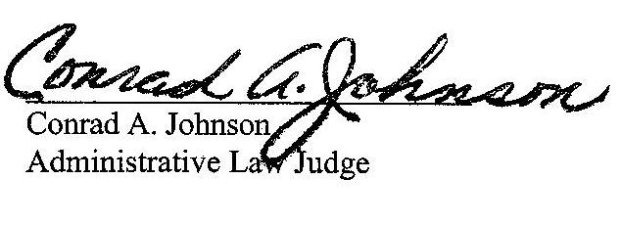
Date: October 27, 2015

F-2015-2490758 - DONALD W SMITH JR v. PHILADELPHIA GAS WORKS
DONALD W SMITH JR
1446 N HOLBART ST
PHILADELPHIA PA 19131
267.441.7348
LAURETO FARINAS ESQUIRE
PHILADELPHIA GAS WORKS
4TH FLOOR
800 W MONTGOMERY AVENUE
PHILADELPHIA PA 19122
215.684.6982
Accepts e-Service

