BEFORE THE
PENNSYLVANIA PUBLIC UTILITY COMMISSION

Kathleen C. Chatters :
:
v. : C-2015-2503895
:
UGI Utilities Inc. :

INTERIM ORDER
GRANTING RESPONDENT’S MOTION FOR HEARING CONTINUANCE

By Notice dated October 7, 2015, the Parties were informed that a telephonic hearing was scheduled before me for this proceeding on Wednesday, November 18, 2015, at 10:00 a.m. On November 9, 2015, via electronic mail, Respondent UGI Utilities Inc. (Respondent or UGI), through its counsel, Larry R. Crayne, Esquire, requested a continuance of the scheduled hearing. As a reason for the request, Attorney Crayne attached to the electronic mail a copy of a November 9, 2015 letter addressed to Complainant Kathleen Chatters (Complainant or Ms. Chatters). In the letter, Attorney Crayne represented that UGI had made arrangements to change Ms. Chatters’ meter and install a short section of fuel line. These arrangements were made to address the concerns raised in the Complaint. Based upon the work to be performed, Attorney Crayne requested a continuance of the November 18, 2015 hearing and stated, “Hopefully after the work is preformed there will not be a need for a hearing.” Attorney Crayne further represented that Complainant had agreed to the continuance of the hearing. The work was scheduled for November 11, 2015 or as soon thereafter as reasonably possible. A copy of the November 9, 2015 letter is attached here to as Attachment A.

Pursuant to 52 Pa.Code § 1.15(b), a request for a change of the scheduled hearing date shall be submitted by motion in writing, filed no later than five (5) days prior to the hearing with the Pennsylvania Public Utility Commission (Commission). The motion must state the facts upon which the request rests. Only for good cause shown will requests for continuance be considered (52 Pa.Code §1.15(b)).
Although Respondent’s November 9, 2015 electronic mail requesting a hearing continuance does not conform to the requirements of a formal motion under Section 1.15(b) of the Commission’s regulations, waiver of this requirement was permitted. Under Section 1.2, 52 Pa. Code § 1.2, a presiding officer at any stage of an action or proceeding may waive a requirement of a rule when necessary or appropriate, if waiver does not adversely affect a substantive right of a party. Such were the circumstances in this case. Therefore, Respondent’s November 9, 2015 electronic mail is treated as a motion.

By electronic mail to me dated November 16, 2015, Attorney Crayne attached a November 13, 2015 letter addressed to Ms. Chatters, and he informed me that the work was performed on Ms. Chatters’ heating equipment on November 11, 2015. “She was pleased with the work, and currently has sufficient pressure to operate her boiler. However, she would like to verify that the work has resolved the issue with her heating equipment this winter,” Attorney Crayne stated. A copy of the November 16, 2015 letter is attached here to as Attachment B.

Attorney Crayne further stated that Ms. Chatters is reluctant to agree to a Certificate of Satisfaction. Therefore, he suggested that the matter could be resolved by delaying the hearing until next spring. If there are no gas line pressure problems by springtime, Ms. Chatters should be willing to agree to a Certificate of Satisfaction, according to Attorney Crayne. In the alternative, Ms. Chatters’ Complaint could be dismissed without prejudice. If she is not satisfied by next spring, she could filed a new complaint, Attorney Crayne maintained. Respondent’s November 16, 2015 electronic mail is treated as an amendment to its earlier motion (amended motion).

I find that the amended motion states good cause to grant a hearing continuance. The meter change and installation of a short section of fuel line by Respondent for Complainant service may have avoided the necessity of a hearing. However, additional time is needed to determine whether the work performed by Respondent has resolved the issue(s) set forth in the Complaint. Accordingly, the amended motion will be granted in the ordering paragraphs below. The hearing will be continued for 120 days. Either Complainant or Respondent may request in writing that the hearing be rescheduled before the expiration of the 120 days. In the event that within 120 days, neither a Certificate of Satisfaction is filed by Respondent, nor a Withdrawal of the Complaint is filed by Complainant then this matter will be rescheduled for hearing and the Parties so notified in writing.

The Parties are encouraged to talk with each other to resolve this matter or some portion thereof. It is the Commission’s policy to encourage settlements. 52 Pa.Code § 5.231.

THEREFORE,

IT IS ORDERED:

- That the continuance requested by Respondent UGI Utilities, Inc., in the matter of Kathleen C. Chatters v. UGI Utilities, Inc., at Docket No. C-2015-2503895 is granted.

- The telephonic hearing is continued for 120 days from the date of this order.

- That either Complainant Kathleen C. Chatters or Respondent UGI Utilities, Inc. may request in writing that the hearing be rescheduled before the expiration of 120 days from the date of this order.

- That in the event 120 days from the date of this order neither a Certificate of Satisfaction has been filed by UGI, nor a Withdrawal of the Complaint has been filed by Ms. Chatters, the Scheduling Staff of the Office of Administrative Law Judge shall reschedule this matter for a telephonic hearing before me and so notify the parties in writing.

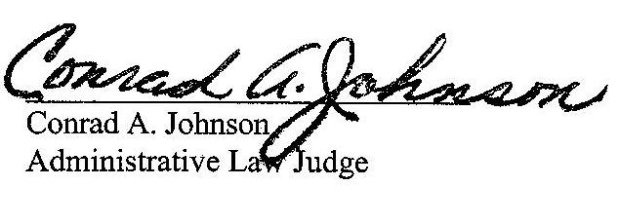
Date: November 17, 2015

ATTACHMENT A

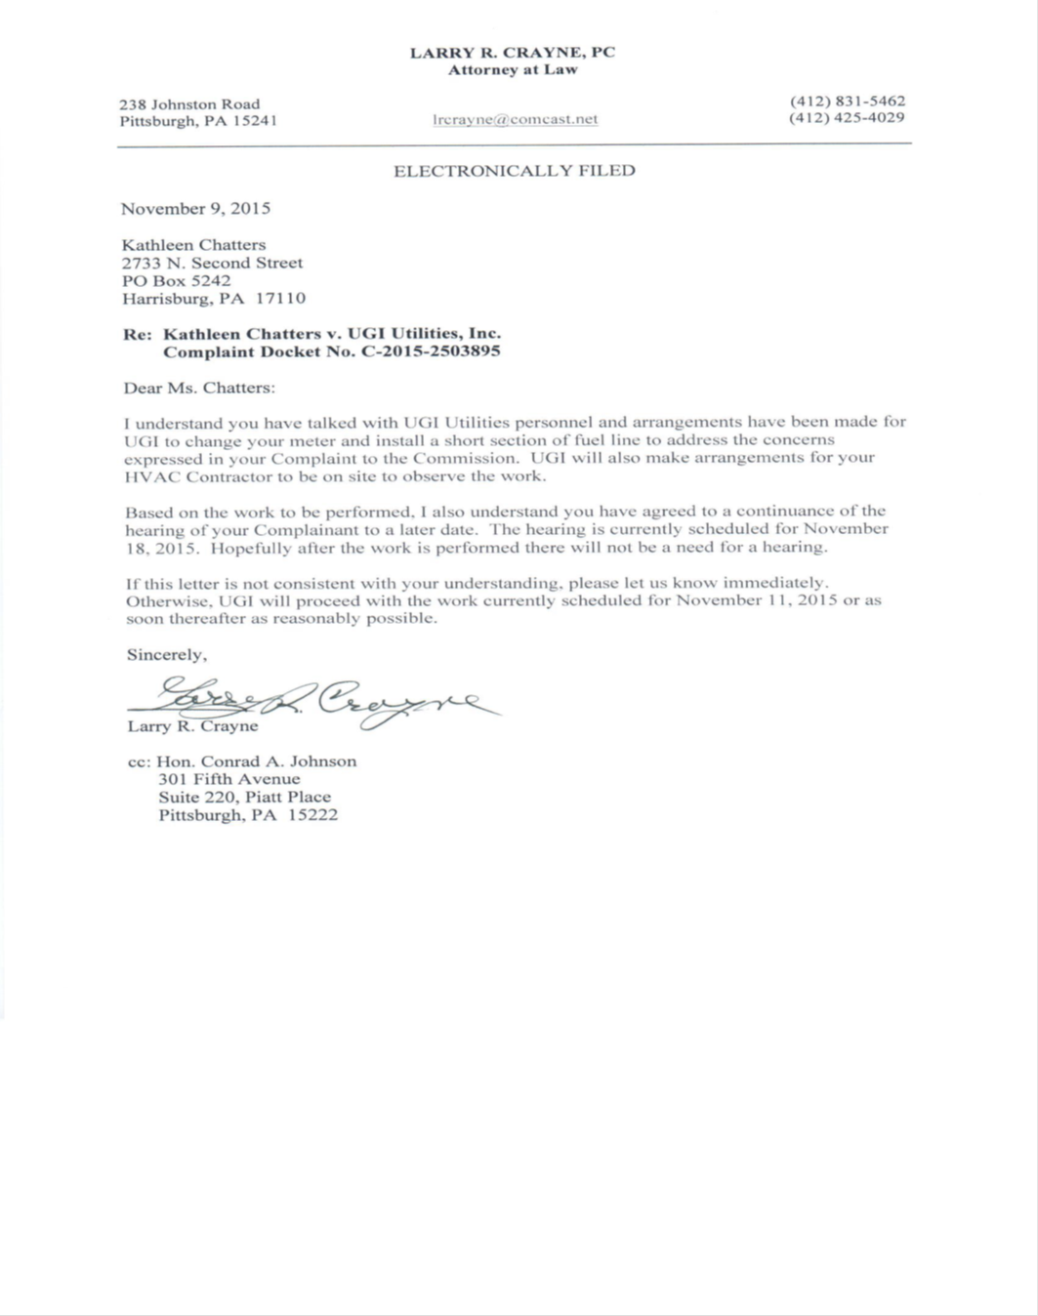

ATTACHMENT B

LARRY R. CRAYNE, PC

Attorney at Law

238 Johnston Road (412) 831-5462
Pittsburgh, PA 15241 lrcrayne@comcast.net (412) 425-4029

November13, 2015

Hon. Conrad A. Johnson
301 Fifth Avenue
Suite 220, Piatt Place
Pittsburgh, PA 15222

Re: Kathleen Chatters v. UGI Utilities, Inc.

Complaint Docket No. C-2015-2503895

Dear Judge Johnson:

The work to accommodate Ms. Chatter heating equipment was performed on November 11, 2015. She was pleased with the work, and currently has sufficient pressure to operate her boiler. However, Ms. Chatters would like to verify that the work has resolved the issue with her heating equipment this winter.

Since Ms. Chatters is reluctant to agree to a Certification of Satisfaction, I suggest two ways to resolve this matter: 1) a hearing of this Complaint could be delayed until next Spring after the winter heating season. If Ms. Chatters experiences no pressure problems the winter with her heating equipment, then she should be willing to agree to a Certification of Satisfaction. 2) The Complaint could be dismissed, without prejudice. Ms. Chatters could then file a new complaint next spring if she is not satisfied.

Please let us know how you wish to proceed.

Sincerely,

Larry R. Crayne

cc: Kathleen Chatters
2733 N. Second Street
PO Box 5242
Harrisburg, PA 17110

C-2015-2503895 - KATHLEEN C CHATTERS v. UGI UTILITIES INC
KATHLEEN C CHATTERS
2733 N SECOND ST
PO BOX 5242
HARRISBURG PA 17110
717.232.8209
LARRY R CRAYNE ESQUIRE
238 JOHNSTON ROAD
PITTSBURGH PA 15241-2556
412.831.5462
Accepts E-service
Representing UGI Utilities, Inc.

