BEFORE THE
PENNSYLVANIA PUBLIC UTILITY COMMISSION

Robert Dean :
:
v. : C-2015-2505667
:
Duquesne Light Company :

FIRST INTERIM ORDER
GRANTING RESPONDENT’S MOTION FOR HEARING CONTINUANCE

By Hearing Notice dated October 21, 2015, an Initial Telephonic Hearing was scheduled in this proceeding before me for Thursday, December 3, 2015, at 10:00 a.m. On November 5, 2015, Respondent Duquesne Light Company, through its counsel, Jeremy V. Farrell, Esquire, filed a Motion for Continuance of Hearing. The motion stated that Respondent’s counsel had a scheduling conflict. Attorney Farrell is also counsel in a trial in the Westmoreland County Court of Common Pleas scheduled to begin on December 2, 2015, and the trial would likely proceed up to and through December 3, 2015. Accordingly, Respondent requested a two-week continuance of the hearing scheduled in this proceeding. The motion further stated that Complainant Robert Dean had no objection to the request two-week extension.

Pursuant to Section 1.15(b) of the Pennsylvania Public Utility Commission’s (Commission) regulations, 52 Pa.Code § 1.15(b), a request for a change of the scheduled hearing date should be submitted by motion in writing, filed no later than five (5) days prior to the hearing with the Commission. The motion must state the facts upon which the request rests. Only for good cause shown will requests for continuance be considered. Id.

The undersigned finds the motion states good cause to warrant a continuance because Respondent’s counsel’s has conflicting hearing/trial schedule. A notice cancelling the current hearing date and rescheduling the hearing will be issued.
The parties are encouraged to talk with each other to resolve this matter or some portion thereof. It is the Commission’s policy to encourage settlements. 52 Pa.Code § 5.231.

THEREFORE,

IT IS ORDERED:

- That the continuance requested by Respondent Duquesne Light Company in the matter of Robert Dean v. Duquesne Light Company at Docket No. C-2015-2505667 is granted.

- That the Scheduling Staff of the Office of Administrative Law Judge shall reschedule this matter for a telephonic hearing and the parties so notified in writing.

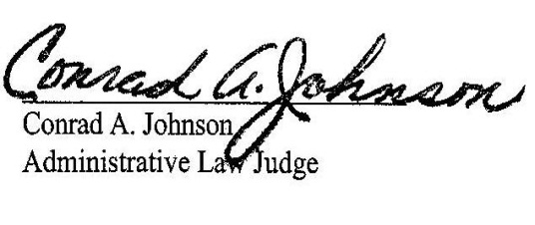
Date: November 17, 2015

C-2015-2505667 - ROBERT DEAN v. DUQUESNE LIGHT COMPANY
ROBERT DEAN
5704 LIBRARY RD
BETHEL PARK PA 15102
412.377.1002
JEREMY V FARRELL ESQUIRE
TUCKER ARENSBERG PC
1500 ONE PPG PLACE
PITTSBURGH PA 15222
412.594.3938
Accepts E-service
Representing Duquesne light Company
LINDSAY N KREPPEL ATTORNEY
TUCKER ARENSBERG PC
1500 ONE PPG PLACE
PITTSBURGH PA 15222
412.594.5640
Accepts E-service
Representing Duquesne light Company

