 | COMMONWEALTH OF PENNSYLVANIA  PENNSYLVANIA PUBLIC UTILITY COMMISSION  P.O. BOX 3265, HARRISBURG, PA 17105-3265 | IN REPLY PLEASE REFER TO OUR FILE

November 19, 2015
A-2013-2374997

TO ALL PARTIES

Application of the Department of Transportation of the Commonwealth of Pennsylvania for the approval to alter the grade crossing by the installation of automatically operated flashing-light railroad crossing warning signals with short arm gates where Diller Avenue crosses, at grade, (DOT No. 517 759 D) a single track of Norfolk Southern Railway Company in New Holland Borough, Lancaster County; all in accordance with the Federal Highway Grade Crossing Safety Program; and the allocation of costs incident thereto.

To Whom It May Concern:

In accordance with numbered Paragraph 3 of the Commission’s Secretarial Letter dated July 3, 2014 in the above captioned proceeding Norfolk Southern Railway Company has submitted situation and signal design plans for this Commission’s approval.

The plans were received on November 9, 2015 and are entitled: “NEW HOLLAND, PA., CFLGS AT DILLER AVE.,” and consist of twenty-three (23) sheets.

Norfolk Southern Railway Company avers that each party to the proceeding was served with a copy of the plans for review. None of the parties have advised this Commission that it objects to approval of the plans.

Please be advised that the plans have been certified as the correct plans and are hereby approved.

The Parties are reminded that failure to comply with this or any Order or Secretarial Letter in this proceeding may result in an enforcement action seeking civil penalties and/or other sanctions pursuant to 66 Pa. C.S. § 3301.

If you are dissatisfied with the resolution of this matter, you may, as set forth in 52 Pa. Code §§ 1.31 and 5.44, file a Petition for Reconsideration from Staff Action (Petition) with the Commission within twenty (20) days of the date of this letter. The Petition shall be sent to: Secretary, PA Public Utility Commission, P.O. Box 3265, Harrisburg, PA 17105-3265, and must be filed within twenty (20) days, or if no timely request is made, the action will be deemed to be a final action of the Commission.

The Petition MUST include: (1) a written statement (divided into numbered paragraphs) outlining the reasons for the request; (2) the case docket number (it is provided for you at the top right hand corner of this letter); (3) the party on whose behalf the petition is made; (4) a Certificate of Service on the other parties of record; and (5) a Verification with original signature in accordance with 52 Pa. Code § 1.36.

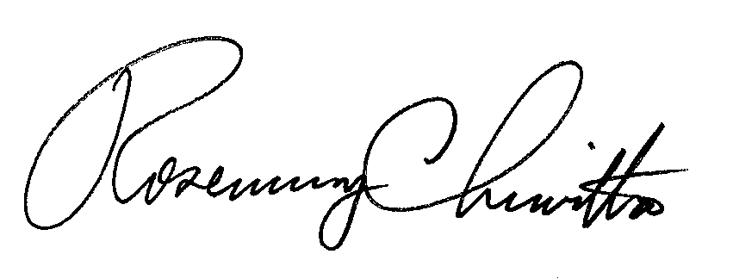
Very truly yours,

Rosemary Chiavetta
Secretary

