 | COMMONWEALTH OF PENNSYLVANIA  PENNSYLVANIA PUBLIC UTILITY COMMISSION  P.O. BOX 3265, HARRISBURG, PA 17105-3265 | IN REPLY PLEASE REFER TO OUR FILE

December 18, 2015
Docket No. R-2015-2468056

THEODORE J GALLAGHER
ASSISTANT GENERAL COUNSEL
NISOURCE
121 CHAMPION WAY SUITE 100
CANONSBURG PA 15317

Re: Supplement No. 238 to Columbia Gas of Pennsylvania, Inc. Tariff Gas Pa. P.U.C. No. 9

Dear Mr. Gallagher:

By Order entered December 3, 2015, the Commission authorized Columbia Gas of Pennsylvania, Inc. (Company) to file a tariff supplement incorporating the terms of the Joint Petition for Partial Settlement and changes to rates, rules and regulations as set forth in Appendix C of the Joint Petition for Partial Settlement filed in the above docketed rate investigation, to produce an annual increase in base rate operating revenues of not more than $28 million. On December 15, 2015, the Company filed Supplement No. 238 Tariff Gas Pa. P.U.C. No. 9 to become effective December 18, 2015.

Commission Staff has reviewed the tariff revisions and found that suspension or further investigation does not appear warranted at this time. Therefore, in accordance with 52 Pa. Code, Supplement No. 238 Tariff Gas Pa. P.U.C. No. 9 is effective by operation of law according to the effective dates contained on each page of the supplement. However, this is without prejudice to any formal complaints timely filed against said tariff revision.

If you have any questions in this matter, please contact Marissa Boyle, Bureau of Technical Utility Services, at 717-787-7237 or maboyle@pa.gov.

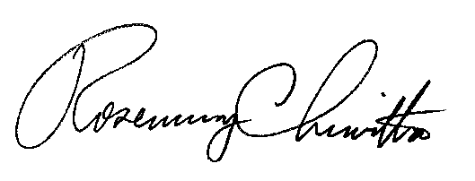

Sincerely,

Rosemary Chiavetta
Secretary

