COMMONWEALTH OF PENNSYLVANIA
PENNSYLVANIA PUBLIC UTILITY COMMISSION
P O BOX 3265, HARRISBURG PA 17105-3265
Formal Rate Complaint
Docket #:C-2016-2528502
Date Served: February 11, 2016

TWIN LAKES UTILITIES INC
C/O JOHN J GALLAGHER ESQ
711 FOREST ROAD
HARRISBURG PA 17112

RE: PA PUC vs TWIN LAKES UTILITIES INC
Rate Case Docket #: R-2015-2506337

Dear Mr. Gallagher:

A Formal Rate Complaint has been filed against you in the above-captioned matter before the Pennsylvania Public Utility Commission by Anthony Ciuffreda.

This true and correct copy of the complaint has been filed of record with the Pennsylvania Public Utility Commission. Both the Pennsylvania Public Utility Code, 66 Pa. C.S. Section 702, and the Commission’s regulations, 52 Pa. Code Section 1.53, require the Commission to serve on each party named in a Formal Rate Complaint a copy of the complaint.

Within ten (10) days from the above date of service, you may either satisfy or answer this complaint in accordance with the provisions of 52 Pa Code, §5.61(d).

When filing your answer to the Formal Rate Complaint, please reference the “Formal Rate Complaint Docket Number” located in the upper-right hand corner of this Notice.

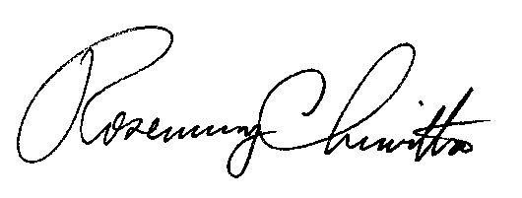
Very Truly Yours,

Rosemary Chiavetta
Secretary

(SEAL)
Certified Mail
Return Receipt Requested
RC:alw

