February 25, 2016

CARLOS GARCIA
ASAP TRANSPORT LLC
4413 MALTA STREET
PHILADELPHIA PA 19124

Dear Sir/Madam:

On February 19, 2016, the Commission received your Application of Motor Common Carrier in Paratransit Service. Upon initial review, the Application has been determined to be deficient for the following reasons:

- As a Limited Liability Company (LLC), please provide on a separate sheet of paper a list of company members and their addresses (even if there is only one).
Pursuant to 52 Pa. Code §1.4, you are required to correct these deficiencies. Failure to do so within 20 days of the date of this letter will result in the Application being returned unfiled.
Please return your items to the above listed address and address to the attention of Secretary Chiavetta.

Should you have any questions pertaining to your application, please contact our Bureau at 717-772-7777.

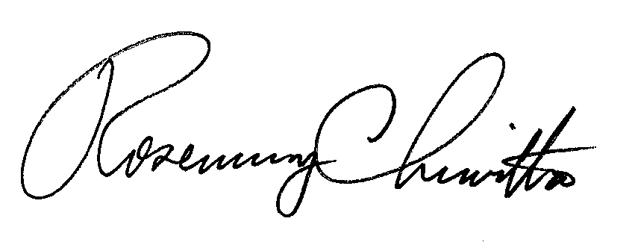
Sincerely,

Rosemary Chiavetta
Secretary

alw

