 | COMMONWEALTH OF PENNSYLVANIA  PENNSYLVANIA PUBLIC UTILITY COMMISSION  P.O. BOX 3265, HARRISBURG, PA 17105-3265 | IN REPLY PLEASE REFER TO OUR FILE
April 18, 2016
Docket No. A-2016-2531857
Utility Code: 1217439
CERTIFIED

PETE KISH REGISTERED AGENT
TELCO PROS INC. d/b/a TPI EFFICIENCY CONSULTING
2188 JENNA COURT
BETHLEHAM PA 18020

RE: Natural Gas Supplier License Application of Telco Pros Inc. d/b/a TPI Efficiency Consulting

Dear Mr. Kish:

On February 22, 2016, Telco Pros Inc. d/b/a TPI Efficiency Consulting’s application for a Natural Gas Supplier license was accepted for filing and docketed with the Public Utility Commission. The application was incomplete. In order for us to complete our analysis of your application, the Energy Industry Group requires answers to the attached question(s).

Please be advised that you are directed to forward the requested information to the Commission within 20 days of receipt of this letter. Failure to respond may result in the application being denied. As well, if Telco Pros Inc. d/b/a TPI Efficiency Consulting has decided to withdraw its application, please reply notifying the Commission of such a decision.

Please forward the information to the Secretary of the Commission at the address listed below. When submitting documents, all documents requiring notary stamps must have original signatures. Please note that some responses may be e-filed to your case, http://www.puc.pa.gov/efiling/default.aspx. A list of document types allowed to be e-filed can be found at http://www.puc.pa.gov/efiling/DocTypes.aspx.

Rosemary Chiavetta, Secretary |  | Rosemary Chiavetta, Secretary
Pennsylvania Public Utility Commission | or | Pennsylvania Public Utility Commission
P.O. Box 3265 |  | 400 North Street
Harrisburg, PA 17105-3265 |  | Harrisburg, PA 17120

Your answers should be verified per 52 Pa Code § 1.36. Accordingly, you must provide the following statement with your responses:

I, ________________, hereby state that the facts above set forth are true and correct to the best of my knowledge, information and belief, and that I expect to be able to prove the same at a hearing held in this matter. I understand that the statements herein are made subject to the penalties of 18 Pa. C.S. § 4904 (relating to unsworn falsification to authorities).

The blank should be filled in with the name of the appropriate company representative, and the signature of that representative should follow the statement.

In addition, to expedite completion of the application, please also e-mail the information to Natalie Boyer at naboyer@pa.gov. Please direct any questions to Natalie Boyer, Bureau of Technical Utility Services, at naboyer@pa.gov (preferred) or (717) 772-0613.

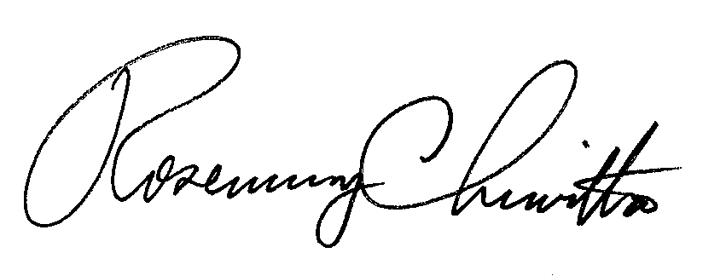
Sincerely,

Rosemary Chiavetta
Secretary

Enclosure

Docket No. A-2016-2531857
Telco Pros Inc. d/b/a TPI Efficiency Consulting
Data Request

- Reference Application, Section 2.b, State Filings – Please provide application documentation for Applicant’s Articles of Incorporation.

- Reference Application, Section 7.b, Financial Fitness – Applicant failed to provide any documentation to prove financial fitness. Please provide documentation of the types listed in Section 7.b. Applicant can elect to mark submitted information as confidential.

- Reference Application, Section 7.f, Taxation – Please provide a fully completed tax certification statement, Applicant failed to complete it. Applicant can elect to mark submitted information as confidential.

- Reference Application, Section 8.a, Technical Fitness – In the resume for Roger Zona, Applicant states Telco Pros Inc. operates nationwide. Please provide licenses from other states in which Applicant is authorized to operate.

