 | COMMONWEALTH OF PENNSYLVANIA  PENNSYLVANIA PUBLIC UTILITY COMMISSION  P.O. BOX 3265, HARRISBURG, PA 17105-3265 | IN REPLY PLEASE REFER TO OUR FILE

April 25, 2016
C-2016-2537649

KEENIA JOSEPH
NORTH AMERICAN POWER AND GAS LLC
ONE MARSHALL STREET
NORWALK CT 06854
PAUL E RUSSELL ESQUIRE
PPL ELECTRIC UTILITIES CORPORATION
2 NORTH NINTH STREET
ALLENTOWN PA 18101

Sylvia M. Carter
v.
PPL Electric Utilities Corporation and North American Power & Gas LLC

Dear Sir/Madam:

Attached is a copy of an amended complaint filed on behalf of the complainant in the above titled proceeding.

Such answer as you desire to make to the amended complaint should be filed in this Office and served upon the complainant within twenty days from receipt of this letter.

Very truly yours,

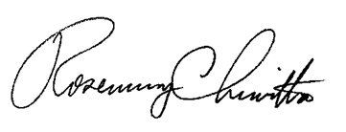Rosemary Chiavetta
Secretary

RC:alw

