BEFORE THE
PENNSYLVANIA PUBLIC UTILITY COMMISSION

B. Elisa Sanders :
:
v. : F-2015-2508203
:
PECO Energy Company :

INTERIM ORDER
CLOSING THE HEARING RECORD

AND NOW, the transcript of the April 4, 2016 initial hearing in this case having been filed with the Commission’s Secretary’s Bureau in Harrisburg on April 20, 2016; and a copy of the transcript having been received by the undersigned in Pittsburgh on May 3, 2016; and no further hearings in this matter are to be scheduled or held.

THEREFORE,

IT IS ORDERED:

- That the hearing record at Docket No. F-2015-2508203 is closed.

2. That the Initial Decision in this case shall be prepared and issued.

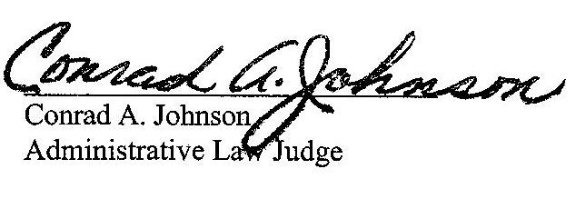
Date: May 5, 2016

F-2015-2508203 - B ELISA SANDERS v. PECO ENERGY COMPANY
B ELISA SANDERS
1926 BERKS ST
PHILADELPHIA PA 19121
267.243.9137
SHAWANE L LEE ESQUIRE
EXELON BUSINESS SERVICES
2301 MARKET STREET S23-1
PO BOX 8699
PHILADELPHIA PA 19101-8699
215.841.6841
-ACCEPTS ELECTRONIC SERVICE-

