NOTICE

PENNSYLVANIA PUBLIC UTILITY COMMISSION

Petition of Duquesne Light Company

P-2016-2543140. Duquesne Light Company. Petition of Duquesne Light Company for approval of a default service plan for the period June 1, 2017, through May 31, 2021.
Formal protests, petitions to intervene and answers must be filed in accordance with 52 Pa. Code (relating to public utilities). Filings must be made with the Secretary of the Pennsylvania Public Utility Commission, 400 North Street, Harrisburg, PA 17120, with a copy served on the petitioner and a copy provided to the Administrative Law Judge on or before June 6, 2016. The documents filed in support of the petition are available for inspection and copying at the Office of the Secretary between 8 a.m. and 4:30 p.m., Monday through Friday, and at the petitioner's business address.
Applicant: Duquesne Light Company
Through and By Counsel: Michael W. Gang, Anthony D. Kanagy, Post & Schell, P.C., 17 North Second Street, 12th Floor, Harrisburg, PA 17101-1601
Tishekia Williams, Duquesne Light Company, 16th Floor, 411 Seventh Avenue, Pittsburgh, PA 15219

Notice
An initial prehearing conference on the previously-captioned case will be held as follows:
Date: | Friday, June 10, 2016
Time: | 10 a.m.
Location: | 2nd Floor Hearing Room—Pittsburgh Parties  Piatt Place  Suite 220  301 Fifth Avenue  Pittsburgh, PA 15222
Location: | Hearing Room _4_—Harrisburg Parties  Plaza Level  Commonwealth Keystone Building  400 North Street  Harrisburg, PA
Presiding: | Administrative Law Judge Conrad A. Johnson  Piatt Place  Suite 220  301 5th Avenue  Pittsburgh, PA 15222  (412) 565-3550  Fax: (412) 565-5692
Individuals representing themselves are not required to be represented by an attorney. All others (corporation, partnership, association, trust or governmental agency or subdivision) must be represented by an attorney. An attorney representing you should file a Notice of Appearance before the scheduled prehearing conference date.
Persons with a disability who wish to attend the prehearing conference should contact the Pennsylvania Public Utility Commission (Commission) to make arrangements for their special needs. Call the scheduling office at the Commission at least 5 business days prior to the hearing to submit a request.
For persons who require an interpreter to participate in the prehearing conference, the Commission will make every reasonable effort to have an interpreter present. Call the scheduling office at the Commission at least 10 business days prior to the hearing to submit a request.
• Scheduling Office: (717) 787-1399
• Pennsylvania AT&T Relay Service number for persons who are deaf or hearing-impaired: (800) 654-5988

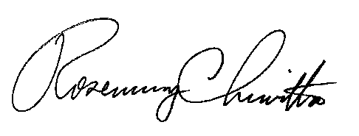
BY THE COMMISSION

Rosemary Chiavetta
Secretary

