BEFORE THE
PENNSYLVANIA PUBLIC UTILITY COMMISSION

Alderwoods (Pennsylvania), Inc., a wholly :
owned subsidiary of Service Corporation :
International, t/a Burton L. Hirsch Funeral Home :
:
v. : C-2016-2522634
:
Duquesne Light Company :

THIRD INTERIM ORDER
GRANTING THE PARTIES’CONSENT MOTION
TO CONTINUE PREHEARING CONFERENCE

By notice dated April 7, 2016, the Parties were informed that an initial prehearing conference was scheduled before me for this proceeding on Tuesday, May 17, 2016, at 10:00 a.m. On April 12, 2016, I issued an interim order directing the Parties to file by Friday, May 13, 2016, their prehearing memoranda setting forth a brief history of the proceeding, the issues they intended to present, a listing of their proposed witnesses and the subject of their testimony, and copies of any exhibits or documents they intended to present at the hearing.

On May 3, 2016, the Parties filed a Consent Motion to Continue Prehearing Conference. In the motion, Respondent Duquesne Light represented that its authorized representative and one of its attorneys had a scheduling conflict on May 17, 2016, in another matter pending before the Commission. The Parties also submitted that Complainant Hirsch Funeral Home had filed a Petition for Interlocutory Review, which is pending. The Parties asserted that under 52 Pa.Code § 5.303, the Commission has thirty days in which to respond to the Petition.

Pursuant to 52 Pa.Code § 1.15(b), a request for a change of the scheduled prehearing hearing conference date shall be submitted by motion in writing, filed no later than five (5) days prior to the hearing with the Pennsylvania Public Utility Commission (Commission). The motion must state the facts upon which the request rests. Only for good cause shown will requests for continuance be considered (52 Pa.Code § 1.15(b)).

After due consideration, I will grant the motion in the ordering paragraph below. Additionally, I will extend the time for the filing of the Parties’ memoranda.

The Parties are encouraged to talk with each other to resolve this matter or some portion thereof. It is the Commission’s policy to encourage settlements. 52 Pa.Code § 5.231.

THEREFORE,

IT IS ORDERED:

- That the Complainant’s and Respondent’s Consent Motion to Continue Prehearing Conference scheduled for May 17, 2016, in this proceeding at Docket No. C-2016-2522634 is granted.

2. That the date each Party must file and distribute its prehearing memorandum setting forth a brief history of the proceeding, the issues they intended to present, a listing of their proposed witnesses and the subject of their testimony, and copies of any exhibits or documents they intended to present is extended from May 13, 2016, to Friday, May 27, 2016, by 4:00 p.m.

3. That the Second Interim Order Concerning Prehearing Conference issued on April 12, 2016, shall remain in effect, except as modified by ordering paragraphs 1 and 2 above.

4. That the Scheduling Staff of the Office of Administrative Law Judge shall reschedule this matter for an in-person prehearing conference for the next available date in June 2016 and so notify the parties in writing.
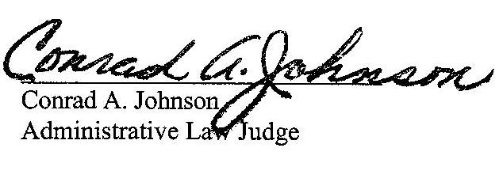

Date: May 11, 2016
ALDERWOODS (PENNSYLVANIA), INC., A WHOLLY OWNED SUBSIDIARY OF SERVICE CORPORATION INTERNATIONAL, T/A BURTON L. HIRSCH FUNERAL HOME v. DUQUESNE LIGHT COMPANY

ALAN J CHARKEY ESQUIRE
WHITE AND WILLIAMS LLP
ONE LIBERTY PLACE
1650 MARKET STREET SUITE 1800
PHILADELPHIA PA 19103
215.864.6312
Accepts E-service
Representing Complainant

*JEREMY V FARRELL ESQUIRE
*BRADLEY S TUPI ESQUIRE
ERIN BECKER CONLIN ESQUIRE
TUCKER ARENSBERG PC
1500 ONE PPG PLACE
PITTSBURGH PA 15222
412.566.1212
*Accepts E-service
Representing Duquesne Light Company

TISHEKIA WILLIAMS ESQUIRE
DUQUESNE LIGHT COMPANY
411 SEVENTH AVENUE
16TH FLOOR
PITTSBURGH PA 15219
412.393.1541
Accepts E-service
Representing Duquesne Light Company

