COMMONWEALTH OF PENNSYLVANIA
PENNSYLVANIA PUBLIC UTILITY COMMISSION
400 NORTH STREET, HARRISBURG PA 17105-3265
Formal Complaint
Docket #: C-2016-2546125
Date Served: May 19, 2016

WILLIAM E. LEHMAN, ESQUIRE
HAWKE, MCKEON & SNISCAK, L.L.P.
100 NORTH 10TH STREET
HARRISBURG, PA 17101

THOMAS J. SNISCAK, ESQUIRE
HAWKE, MCKEON & SNISCAK, L.L.P.
100 NORTH 10TH STREET
HARRISBURG, PA 17101

RE:
DSIC Case Docket #: P-2015-2464242

Dear Mr. Lehman:

A Formal Complaint has been filed against you in the above-captioned matter before the Pennsylvania Public Utility Commission by Judith Boyskey.

This true and correct copy of the complaint has been filed of record with the Pennsylvania Public Utility Commission. Both the Pennsylvania Public Utility Code, 66 Pa. C.S. and the Commission’s regulations at 52 Pa. Code Section 1.53, requires the Commission to serve on each party named in a Formal Complaint a copy of the complaint.

Within twenty (20) days from the above date of service, you may either satisfy or answer this complaint in accordance with the provisions of 52 Pa Code, §5.61(a).

When filing your answer to the Formal Complaint, please reference the “Formal Complaint Docket Number” located in the upper-right hand corner of this Notice.

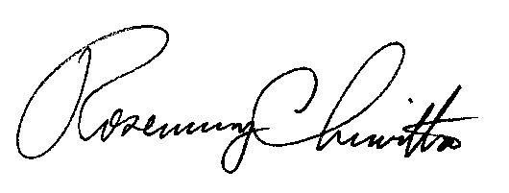
Very Truly Yours,

Rosemary Chiavetta
Secretary

(SEAL)

Certified Mail
Return Receipt Requested

