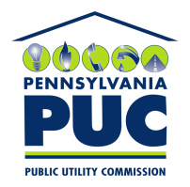 | COMMONWEALTH OF PENNSYLVANIA  PENNSYLVANIA PUBLIC UTILITY COMMISSION  400 North Street, Keystone Building, Second Floor  Harrisburg, Pennsylvania 17120 | IN REPLY PLEASE REFER TO OUR FILE

June 1, 2016

Cheryl Lecoe
ADL High Voltage Inc.
PO Box 1569
Keller TX 76244-1569

RE: Duplicate Financial Instrument
ADL High Voltage Inc.
A-2010-2199907

Dear Ms. Lecoe:

Please find under cover of this letter the Bond Continuation Certificate your company filed with the Commission on behalf of ADL High Voltage Inc. because it is a duplicate of the continuation certificate already on file.

The Commission requires a supplier to file a current and active original bond, letter of credit, continuation certificate, amendment, or other financial instrument as part of a supplier’s licensing requirements under Section 2809(c) of the Pennsylvania Public Utility Code.

As this continuation certificate was previously filed on December 22, 2015, no further action is required on your part at the time.

Sincerely,

Rosemary Chiavetta
Secretary of the Commission

Enclosures
RC:alw

