May 19, 2016

ERNEST J DELBO
BLACK DIAMOND CAB COMPANY INC
212 WEST INDEPENDENCE ST
SHAMOKIN PA 17872

Dear Mr. Delbo:

On May 5, 2016, the Commission received your Application of Black Diamond Cab Company, Inc. Upon initial review, the Application has been determined to be deficient for the following reasons:

- Filing fee. Personal and checks drawn from a corporate account are not accepted. Filing fee must be in the form of a certified check or money order (as stated in the application instructions).
Pursuant to 52 Pa. Code §1.4, you are required to correct these deficiencies. Failure to do so within 20 days of the date of this letter will result in the Application being returned unfiled.
Please return your items to the above listed address and address to the attention of Secretary Chiavetta.

Should you have any questions pertaining to your application, please contact our Bureau at 717-772-7777.

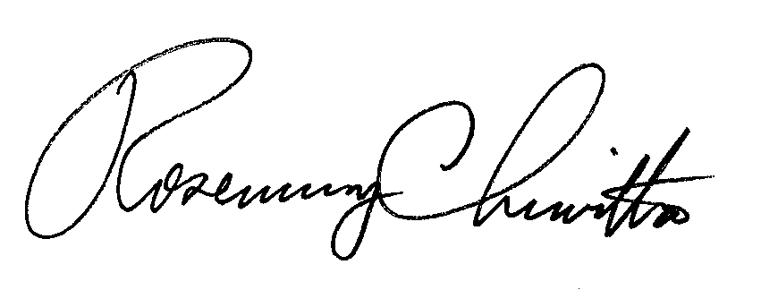
Sincerely,

Rosemary Chiavetta
Secretary

ane

