 | COMMONWEALTH OF PENNSYLVANIA  PENNSYLVANIA PUBLIC UTILITY COMMISSION  400 NORTH STREET 2ND FLOOR, HARRISBURG, PA 17120 | IN REPLY PLEASE REFER TO OUR FILE
Date Served: June 7, 2016
C-2016-2543582
VIA CERTIFIED MAIL

JAMES A RIGGINS JR
PO BOX 484
SADSBURYVILLE PA 19369

RE: BUREAU OF INVESTIGATION AND ENFORCEMENT
V
JAMES A RIGGINS JR

TO WHOM IT MAY CONCERN:

Please know we are returning the enclosed check, check # 193 in the amount of $250.00, because the Commission cannot accept either personal or checks drawn from a corporate account. This will not affect the timeliness of your filing or in answering a complaint.

You may void the check(s) to avoid incurring any cancellation fees from your bank. Please send us a replacement for the amount of the fee or civil penalty in the form of a CERTIFIED CHECK OR MONEY ORDER MADE PAYABLE TO THE “COMMONWEALTH OF PENNSYLVANIA.”

Sincerely,
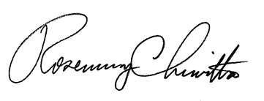
Rosemary Chiavetta
Secretary of the Commission

Enclosure

RC: wjz

