PENNSYLVANIA
PUBLIC UTILITY COMMISSION
Harrisburg, PA 17105-3265
 |  | Public Meeting held June 9, 2016
Commissioners Present:

Gladys M. Brown, Chairman
Andrew G. Place, Vice Chairman
John F. Coleman, Jr.
Robert F. Powelson

Hickory Telephone Company  2016 Annual Price Stability Index / Service Price Index Filing and  Supplement No. 145 to Hickory Telephone Company Tariff PA P.U.C. No. 6 |  |  | R-2016-2540407
Hickory Telephone Company Amended Alternative Regulation and Network Modernization |  |  | P-00981431F1000
ORDER
BY THE COMMISSION:
I. BACKGROUND
Before us for disposition is the Hickory Telephone Company (Hickory or Company) annual 2016 Annual Price Stability Index/Service Price Index Filing and the associated revenue increase. The Company’s filing was made under the provisions of Act 183 of 2004, P.L. 1398 (66 Pa. C.S. §§ 3011-3019) (Chapter 30) and pursuant to the Company’s Alternative Regulation and Network Modernization Plan (Chapter 30 Plan) that this Commission approved at Docket No. P-00981431F1000.
As a result of the passage of Act 183 of 2004, companies with Chapter 30 Plans are entitled to significantly lower inflation offset values within their respective price cap formulas in exchange for a commitment to accelerated broadband deployment. Inflation offsets previously ranging from 2% to 2.93% were reduced to either 0% or 0.5%, depending on each company’s Chapter 30 Plan. In the Company’s case, the inflation offset was reduced from 2% to 0%. Accordingly, annual Price Stability Plan (PSP or Plan) filings have the potential for substantial revenue and rate impacts on end-user consumers.
Under the Company’s PSP, the Price Stability Index (PSI) calculates the allowable change (increase or decrease) in rates for noncompetitive services based, in part, on the Gross Domestic Product Price Index (GDP-PI). The Service Price Index (SPI) tracks the prior changes for noncompetitive services related to PSI. The PSP also contains special provisions for protected services and addresses revenue neutral rate adjustments to the rates for noncompetitive services. The PSP set forth in the Company’s Chapter 30 Plan is a complete substitution of rate base/rate of return regulation. Noncompetitive services are defined as regulated services or business activities that have not been determined or declared to be competitive. Further, the Company’s Chapter 30 Plan acknowledges that nothing in its Plan shall be construed to limit the requirement under 66 Pa. C.S. § 1301 that rates shall be just and reasonable.
II. COMPANY’S FILING
Pursuant to the Plan, Advance Notice was issued on April 15, 2016, informing the Commission of the forthcoming filing. On April 29, 2016, the Company filed its annual PSI/SPI Report using the change in 2014 and 2015 third-quarter GDP-PI, which equates to a 0.913% increase in the PSI. When applied to the previous PSI of 122.78, this produces a new PSI of 123.90. Applying this change to current noncompetitive revenues of $401,297 yields a maximum allowed noncompetitive revenue increase of $3,665.
In its 2016 filing, the Company is implementing a total of $8,655 in actual rate increases. The SPI indicates the cumulative price changes from current and prior years and tracks the actual total price changes for noncompetitive services. Applied to its current SPI of 110.82, the Company’s rate increases produce a new SPI of 113.21.
Consistent with the Commission approved Protective Order entered July 1, 2008, at Docket No. P-2008-2041475 and pursuant to 52 Pa. Code § 5.365, the Company has marked specific information in its filing as proprietary.
The Company served a copy of its PSI/SPI Report on the Office of Small Business Advocate, the Office of Consumer Advocate and the Bureau of Investigation and Enforcement. No complaints were filed and no hearings were held.
The Company proposes to increase local residence single party dial tone line rates by $0.92 monthly, from $19.08 to $20.00 per line. The proposed rate increase will be implemented through Supplement No. 145 to Tariff Telephone PA P.U.C. No. 6, which carries an effective date of July 1, 2016.
III. DISCUSSION
1. Plan Provisions
Part 3.A.8 - 10 of Hickory’s Chapter 30 Plan states the following:
On or before the anniversary date of Plan A . . . the Company shall file with the Commission a PSI and SPI Report. This annual filing may be accompanied by tariffs to implement any required or authorized rate changes . . . A Commission Order must be entered within sixty (60) days of the filing (or such other time as may be otherwise provided herein), otherwise the tariff(s) shall become effective as filed . . . Such rates shall be deemed Commission-made.
Further, Part 3.A.7 of the Hickory’s Chapter 30 Plan contains the following provision regarding banking:
If the Company elects not to increase its rates by the full amount allowed under the terms of the Plan, including exogenous events in a given year, the Company may increase its rates in future years to reflect the full amount of the allowable increase previously deferred. The Company may bank increases for a period not to exceed four (4) consecutive years.
2. PSI/SPI Calculations and Rate Increases
The annual Hickory PSI/SPI filing submissions under Chapter 30 laws must conform to its Commission-approved Amended Chapter 30 Plan. Our review of the calculations submitted by Hickory indicates that they are accurate and consistent with the terms of the Company’s Price Stability Plan formula approved in its Chapter 30 Plan at Docket No. P-00981431F1000. In addition, we are of the opinion that the proposed rate increases appear to be reasonable and in conformance with the Company’s Chapter 30 Plan. Therefore, we shall approve Hickory’s 2016 PSI/SPI calculations and proposed rate increases.
3. Banked Revenues
Hickory will bank the entire $3,665 available in its current filing for future use. We note that the updated banking report included with the Company’s 2016 PSI/SPI filing shows the proposed 2016 revenue increase being withdrawn from the Company’s 2012 banked amount. However, pursuant to the banking terms of the Company’s Chapter 30 Plan, the 2012 banked amount should have been retired in the instant filing. Therefore, we shall adjust the Company’s banked amounts to reflect the retirement of the 2012 banked amount and withdraw the 2016 revenue increase from the Company’s 2013 banked amount.
Previously, the Company’s cumulative bank was $37,927. After the elimination of the remaining unused 2012 banked amount, the reduction for the instant revenue increase and the addition of the 2016 banked amount, the Company has a new cumulative bank of $16,152, which will be carried forward. In accordance with Hickory’s Chapter 30 Plan deferred increases shall carry no interest. The table below shows the breakdown of the Company’s cumulative bank:
Year | Expiration | Banked | Deposit | Withdraw | Remaining Banked Revenue
2012 | 2016 | $ 16,785 |  | $ 16,785 | -
2013 | 2017 | $ 9,149 |  | $ 8,655 | $ 494
2014 | 2018 | $ 5,745 |  |  | $ 5,745
2015 | 2019 | $ 6,248 |  |  | $ 6,248
2016 | 2020 |  | $ 3,665 |  | $ 3,665
Total |  | $ 37,927 | $ 3,665 | $ 25,440 | $ 16,152
IV. CONCLUSION
Our review of the Company’s 2016 PSI/SPI filing indicates the PSI/SPI calculations, proposed rate increases and banked amounts, as modified herein, are consistent with the terms of its Chapter 30 Plan; THEREFORE,
IT IS ORDERED:
- That Hickory Telephone Company’s 2016 PSI/SPI report filed on
April 29, 2016, as amended herein, is in compliance with its Commission-approved Amended Chapter 30 Plan.
2. That the tariffed rate increases proposed by Hickory Telephone Company be permitted to go into effect as filed.
3. That a copy of this Order be served on the Office of Consumer Advocate, Office of Small Business Advocate and the Bureau of Investigation and Enforcement.
4. That the case be marked closed.
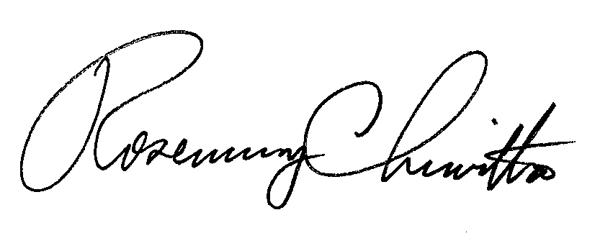
BY THE COMMISSION,

Rosemary Chiavetta
Secretary

(SEAL)

ORDER ADOPTED: June 9, 2016
ORDER ENTERED: June 9, 2016

Petition for Amended Alternative Regulation and Network Modernization Plan of Hickory Telephone Company, Docket No. P-00981431F1000 (Order entered June 3, 2005).

