PENNSYLVANIA
PUBLIC UTILITY COMMISSION
Harrisburg, PA 17105-3265

Application of Reading City Cab LLC :
for approval to transport persons in call or :
demand service from points in Berks and : A-2016-2524649
Lancaster Counties, to points in Pennsylvania :
and return :

FINAL ORDER

In accordance with the provisions of Section 332(h) of the Public Utility Code, 66 Pa. C.S. §332(h), the decision of Administrative Law Judge David A. Salapa dated May 5, 2016, has become final without further Commission action;

THEREFORE,

IT IS ORDERED:

1. That the preliminary objections of Reading City Cab, LLC to the protest filed by J&J Leasing and Rentals, Inc. at Docket No. A-2016-2524649 are sustained.

2. That the protest of J&J Leasing and Rentals, Inc. is dismissed for lack of standing.

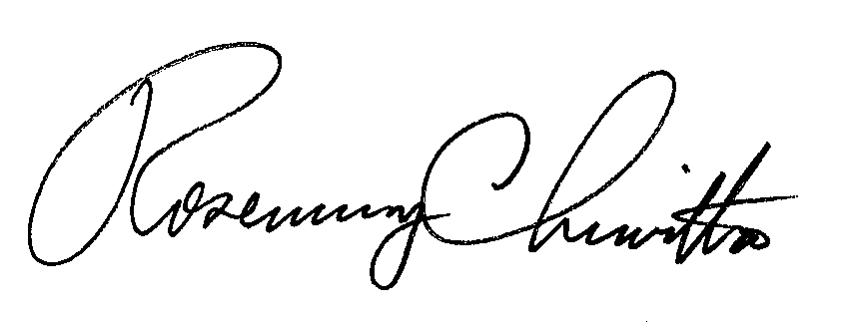
BY THE COMMISSION,

Rosemary Chiavetta
Secretary

(SEAL)

ORDER ENTERED: June 24, 2016

