COMMONWEALTH OF PENNSYLVANIA
PENNSYLVANIA PUBLIC UTILITY COMMISSION
400 NORTH STREET
HARRISBURG PA 17120
IN REPLY PLEASE
REFER TO OUR FILE
Secretary
717-772-7777
June 28, 2016
A-2016-2553414

MICHAEL A. SENFF, PRESIDENT
ADVANTAGE ENERGY PARTNERS LLC
2009 MACKENZIE WAY, SUITE 100
CRANBERRY TOWNSHIP, PA 16066

MEGAN ROONEY, ACCOUNT MANAGER
LICENSELOGIX
140 GRAND STREET, SUITE 300
WHITE PLAINS, NY 10601

Dear Mr. Senff:

Please know we have received your Application and filing fee to become a supplier of natural gas services in the Commonwealth of Pennsylvania. The docket number assigned to your application is A-2016-2553414.
52 Pa. Code §62.109(b) states:
“Completed applications, with all supporting documentation, including any documentation or clarifying information requested by Commission staff, if unprotested, will be processed within 45 days after acceptance by the Commission. If the application is not processed within the time period, the application will be deemed approved. The review period may be extended for a reasonable period of time by Secretarial Letter.”
In addition, the Commission is extending the review period for consideration of the Application for authority to market natural gas services for one hundred and twenty (120) days or until further order of the Commission.
If you are dissatisfied with the resolution of this matter, you may, as set forth in 52 Pa. Code §5.44, file a petition with the Commission within twenty (20) days of the date of this letter.
Should you have any questions pertaining to your application, please contact our Bureau of Technical Utility Services at 717-783-5242.

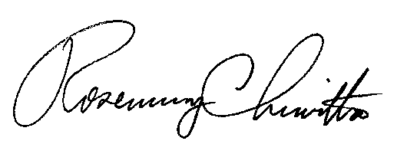
Sincerely,

Rosemary Chiavetta
Secretary

RC:AEL

