BEFORE THE
PENNSYLVANIA PUBLIC UTILITY COMMISSION

Amy Kush :
:
v. : C-2016-2533227
:
Pennsylvania-American Water Company :

INTERIM ORDER CLOSING THE HEARING RECORD

AND NOW, the transcript of the June 9, 2016 initial hearing in this case having been filed with the Commission’s Secretary’s Bureau in Harrisburg on June 30, 2016; and a copy of the transcript having been received by the undersigned in Pittsburgh on July 8, 2016; and no further hearings in this matter are to be scheduled or held,

THEREFORE,

IT IS ORDERED:

- That the hearing record at Docket No. C-2016-2533227 is closed.

3. That the Initial Decision in this case shall be prepared and issued.

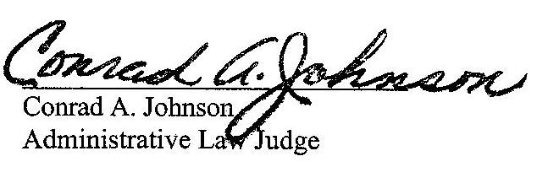
Dated: July 13, 2016
C-2016-2533227 - AMY KUSH v. PENNSYLVANIA -AMERICAN WATER COMPANY
AMY KUSH
258 FREDERICK STREET
KINGSTON PA 18704
570.817.4722
MICHAEL A GRUIN ESQUIRE
STEVENS & LEE
16TH FLOOR
17 NORTH SECOND STREET
HARRISBURG PA 17101
717.255.7365
Accepts E-service
Representing Pennsylvania-American Water Company

