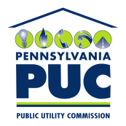 | COMMONWEALTH OF PENNSYLVANIA  PENNSYLVANIA PUBLIC UTILITY COMMISSION  400 North Street, HARRISBURG, PA 17120 | IN REPLY PLEASE REFER TO OUR FILE

Date of Service: July 18, 2016 Docket Number: C-2016-2556988

CARMEN MALDONADO
THE NEW YELLOW CAB LLC
1118 NORTH 3RD STREET, 1ST FLOOR
HARRISBURG, PA 17102

Bureau of Investigation and Enforcement
v.
THE NEW YELLOW CAB LLC

Dear Sir/Madam:

The Pennsylvania Public Utility Commission has delegated its authority to initiate prosecutory proceedings to several of its Commission bureaus with enforcement responsibilities. Pursuant to this delegated authority and Section 701 of the Public Utility Code, 66 Pa. C.S. § 701, Bureau of Investigation and Enforcement staff has filed the attached Complaint against you seeking a monetary penalty and/or revocation of your Certificate of Public Convenience.

Very truly yours,


Rosemary Chiavetta
Secretary

RC:AEL

