BEFORE THE
PENNSYLVANIA PUBLIC UTILITY COMMISSION

Gregory and Lavone Weaver :
:
v. : C-2016-2536424
:
People Natural Gas Company Equitable Division :

INTERIM ORDER CLOSING THE HEARING RECORD

AND NOW, the transcript of the June 16, 2016 initial hearing in this case having been filed with the Commission’s Secretary’s Bureau in Harrisburg on July 5, 2016; and a copy of the transcript having been received by the undersigned in Pittsburgh on July 11, 2016; and no further hearings in this matter are to be scheduled or held,

THEREFORE,

IT IS ORDERED:

- That the hearing record at Docket No. C-2016-2536424 is closed as of July 11, 2016.

3. That the Initial Decision in this case shall be prepared and issued.

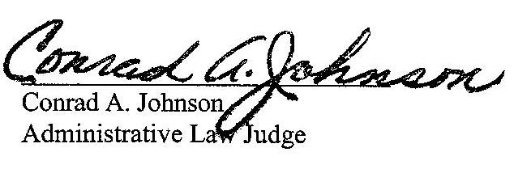
Dated: July 20, 2016

C-2016-2536424 – GREGORY & LAVONE WEAVER V. PEOPLES NATURAL GAS COMPANY EQUITABLE DIVISION
Revised 5-3-16
GREGORY & LAVONE WEAVER
158 SECOND STREET
CLARKSVILLE PA 15322
724.377.0708
JENNIFER L PETRISEK ESQUIRE
PEOPLES NATURAL GAS COMPANY LLC - EQUITABLE DIVISION
225 NORTH SHORE DRIVE
PITTSBURGH PA 15212
412.208.6834
Accepts Electronic Service

