 | COMMONWEALTH OF PENNSYLVANIA  PENNSYLVANIA PUBLIC UTILITY COMMISSION  P.O. BOX 3265, HARRISBURG, PA 17105-3265 | IN REPLY PLEASE REFER TO OUR FILE

August 11, 2016
A-6418573
A-2016-2531858

ASAP TRANSPORT LLC
4413 MALTA ST
PHILADELPHIA PA 19124

RE: A-2016-2531858 – Application of ASAP Transport, LLC, 4413 Malta St., Philadelphia, PA 19124

To Whom It May Concern:

The purpose of this Letter is to advise you that your Application, Docket No. A-2016-2531858, has been DENIED by the Pennsylvania Public Utility Commission (Commission). The Commission has determined that a Certificate of Public Convenience WILL NOT BE GRANTED for the following reason(s):

- Failure to respond to a Commission data request. On April 27, 2016, the Commission requested verified statement and verified statements of the applicant which were required to further process the application; the applicant was afforded 30 days to do so, and was further provided with guidance on how to request a filing extension. To date, more than 90 calendar days later, the data request has remained unanswered.

For this reason(s), your application is DENIED and DISMISSED. If you disagree with this decision, you may request that the Commission reconsider this matter under 52 Pa. Code §5.44. A petition for reconsideration must be filed with the Commission within twenty (20) days of the date of this Letter. If no timely request for reconsideration is made, this action will be deemed to be the final action of the Commission.

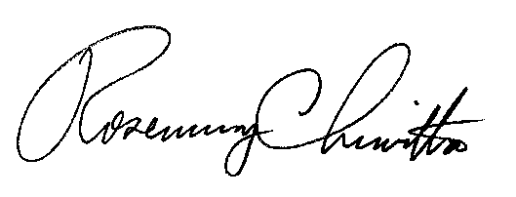 Very truly yours,

Rosemary Chiavetta
Secretary

