 |  | COMMONWEALTH OF PENNSYLVANIA  PENNSYLVANIA PUBLIC UTILITY COMMISSION  400 North Street, HARRISBURG, PA 17120 |  | IN REPLY PLEASE REFER TO OUR FILE  Phone: 717-772-7777
AUGUST 12, 2016

ALL PARTIES OF RECORD

Re: Deree J Norman v. Philadelphia Gas Works
Docket Number: C-2015-2489503

To All Parties of Record:

On August 11, 2016, my office received Exceptions from the Complainant to the Initial Decision of Administrative Law Judge Dennis J Buckley in the above captioned matter. Our review of the filing revealed that no certificate of service or other indication that the parties of record to the case were served with the Complainant’s Exceptions. Therefore, we have enclosed a copy of the Exceptions to constitute service for purposes of 52 Pa. Code 5.533.

Due to the failure of the Complainant to provide service on all the parties of record to the case, and in order to avoid prejudice to any party pursuant to 52 Pa. Code 5.535, the Respondent shall have until August 22, 2016 to file Reply Exceptions.

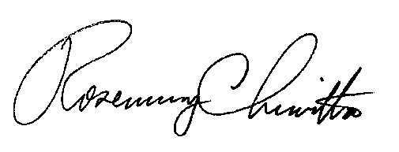
Sincerely,

Rosemary Chiavetta
Secretary

Enclosure
RC: DJ

cc: All Parties of Record
Document Folder

