 |  | COMMONWEALTH OF PENNSYLVANIA  PENNSYLVANIA PUBLIC UTILITY COMMISSION  400 North Street, HARRISBURG, PA 17120 |  | IN REPLY PLEASE REFER TO OUR FILE  Phone: 717-772-7777
AUGUST 4, 2016

FREEDOM LOGISTICS LLC
MARIANNE VETTER
5 DARMOUTH DRIVE STE 301
AUBURN NH 03032

Dear Ms.Vetter:

On July 21, 2016, the Commission received the Application of Freedom Logistics LLC for approval to supply natural gas services to the public in the Commonwealth of PA. Upon initial review, the Application has been determined to be deficient for the following reasons:

- No Original Signature on Cover Letter (Letter is enclosed for Signature)

- No Certificate of Service with Original Signature

- No Articles of Incorporation from New Hampshire

Pursuant to 52 Pa. Code §1.4, you are being advised of these deficiencies and are required to file corrections. Failure to correct the foregoing deficiencies within 20 days of the date of this letter will result in the Application being returned unfiled.
Please return your items to the above listed address and address to the attention of the Office of the Secretary.
If you have any question in regards to this letter, please contact our bureau at (717) 772-7777. Thank you
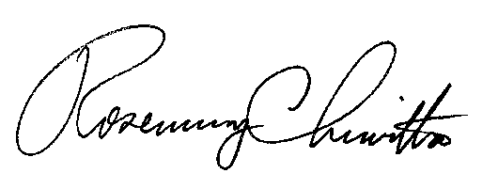
Sincerely,

Rosemary Chiavetta
Secretary

Enclosure
DJ

