 | COMMONWEALTH OF PENNSYLVANIA  PENNSYLVANIA PUBLIC UTILITY COMMISSION  400 NORTH STREET, HARRISBURG, PA 17120 | IN REPLY PLEASE REFER TO OUR FILE
September 1, 2016

ALL PARTIES OF RECORD

Re: George Mandeville v. PPL Electric Utilities Corporation
Docket Number: C-2016-2512838

To All Parties of Record:

On September 1, 2016, my office received Reply Exceptions from the Complainant to the Initial Decision of Administrative Law Judge Conrad A. Johnson in the above captioned matter. Our review of the filing revealed that no certificate of service or other indication that the parties of record to the case were served with the Complainant’s Exceptions. Therefore, we have enclosed a copy of the Reply Exceptions to constitute service for purposes of 52 Pa. Code 5.533.

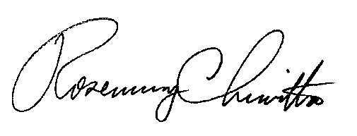
Sincerely,

Rosemary Chiavetta
Secretary

Enclosure
RC: alw

cc: All Parties of Record
Document Folder

