COMMONWEALTH OF PENNSYLVANIA
PENNSYLVANIA PUBLIC UTILITY COMMISSION
P O BOX 3265, HARRISBURG PA 17105-3265
Formal Complaint
Docket #: C-2016-2567132
Date Served: September 20, 2016

Pamela C Polacek, Esquire
Adeolu A Bakare, Esquire
McNees Wallace & Nurick LLC
100 Pine Street
Harrisburg Pa 17108-1166

RE: PA PUC vs WELLSBORO ELECRIC COMPANY
Rate Case Docket #: R-2016-2531551

Dear Pamela Polacek and Adeolu Bakare:

A Formal Complaint has been filed against you in the above-captioned matter before the Pennsylvania Public Utility Commission by the OFFICE OF SMALL BUSINESS ADVOCATE.

This true and correct copy of the complaint has been filed of record with the Pennsylvania Public Utility Commission. Both the Pennsylvania Public Utility Code, 66 Pa. C.S. and the Commission’s regulations at 52 Pa. Code Section 1.53, requires the Commission to serve on each party named in a Formal Complaint a copy of the complaint.

Within ten (10) days from the above date of service, you may either satisfy or answer this complaint in accordance with the provisions of 52 Pa Code, §5.61(d).

When filing your answer to the Formal Complaint, please reference the “Formal Complaint Docket Number” located in the upper-right hand corner of this Notice.

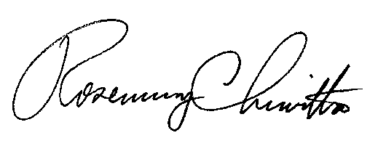
Very Truly Yours,

Rosemary Chiavetta
Secretary
RC:alw

(SEAL)

Certified Mail
Return Receipt Requested

