BEFORE THE
PENNSYLVANIA PUBLIC UTILITY COMMISSION

PENNSYLVANIA PUBLIC UTILITY COMMISSION :
BUREAU OF INVESTIGATION AND ENFORCEMENT :
:
V. : DOCKET NO. C-2016-2567125 :
RAYMOND WHITAKER :
4185 IVANHOE DRIVE :
MONROEVILLE PA 15146 :

COMPLAINT

The Pennsylvania Public Utility Commission (Commission) is a duly constituted agency of the Commonwealth of Pennsylvania empowered to regulate public utilities within the Commonwealth. The Commission has delegated its authority to initiate proceedings which are prosecutory in nature to the Bureau of Investigation and Enforcement and other bureaus with enforcement responsibilities. Pursuant to that delegated authority and Section 701 of the Public Utility Code, the Bureau of Investigation and Enforcement Prosecutory Staff hereby represents as follows:

- That Raymond Whitaker, Respondent, maintains a residence at 4185 Ivanhoe Drive, Monroeville, Pennsylvania,15146.

- That on September 18, 2016, at 9:00 AM, a 2005 Buick sedan, bearing PA registration number JWZ2104, was observed at the The Westin Convention Center, 1000 Penn Avenue, Pittsburgh, Allegheny County, PA. Information from PennDOT indicates the vehicle is owned by the Respondent. The vehicle had a taxi dome light mounted on the roof, which clearly displayed the word “TAXI.” See Appendix A and B.

3. That Respondent, by affixing a taxi dome light to the roof of the vehicle, violated 75 Pa. C.S. §4307. Dome lights are only permitted on vehicles operated by call and demand carriers or food delivery vehicles. The penalty for this violation is $250.

WHEREFORE, the Bureau of Investigation and Enforcement Prosecutory Staff hereby request that the Commission fine Raymond Whitaker, the sum of two hundred and fifty dollars ($250) for the illegal activity described in this Complaint.

Respectfully submitted,

David W. Loucks, Chief
Motor Carrier Enforcement
Bureau of Investigation and Enforcement
P.O. Box 3265
Harrisburg, PA 17105-3265

APPENDIX A

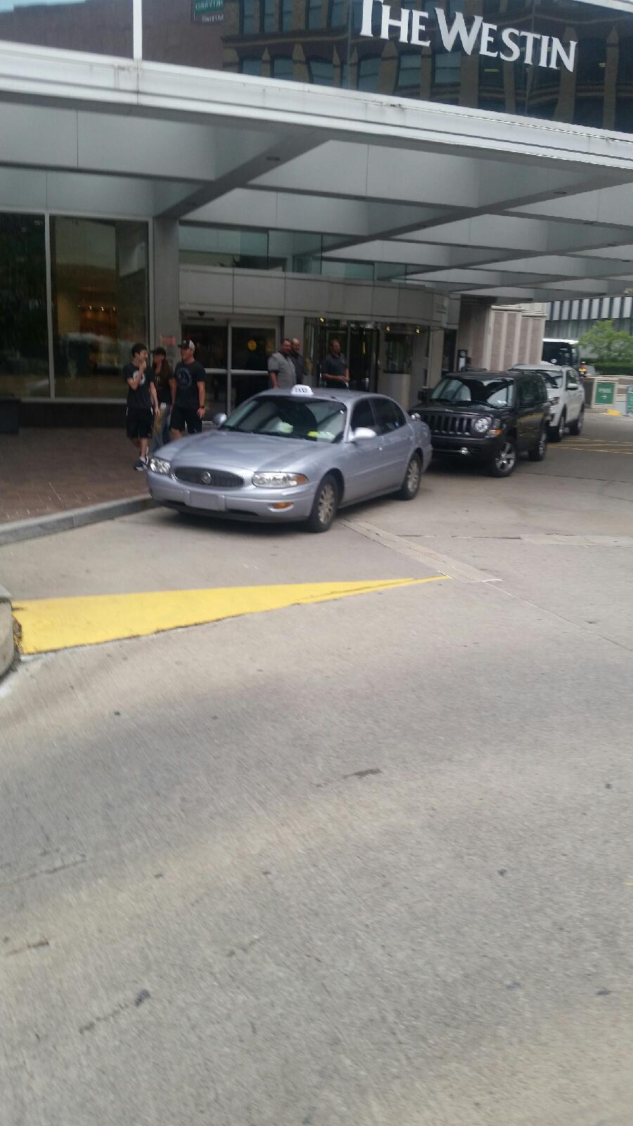

APPENDIX B

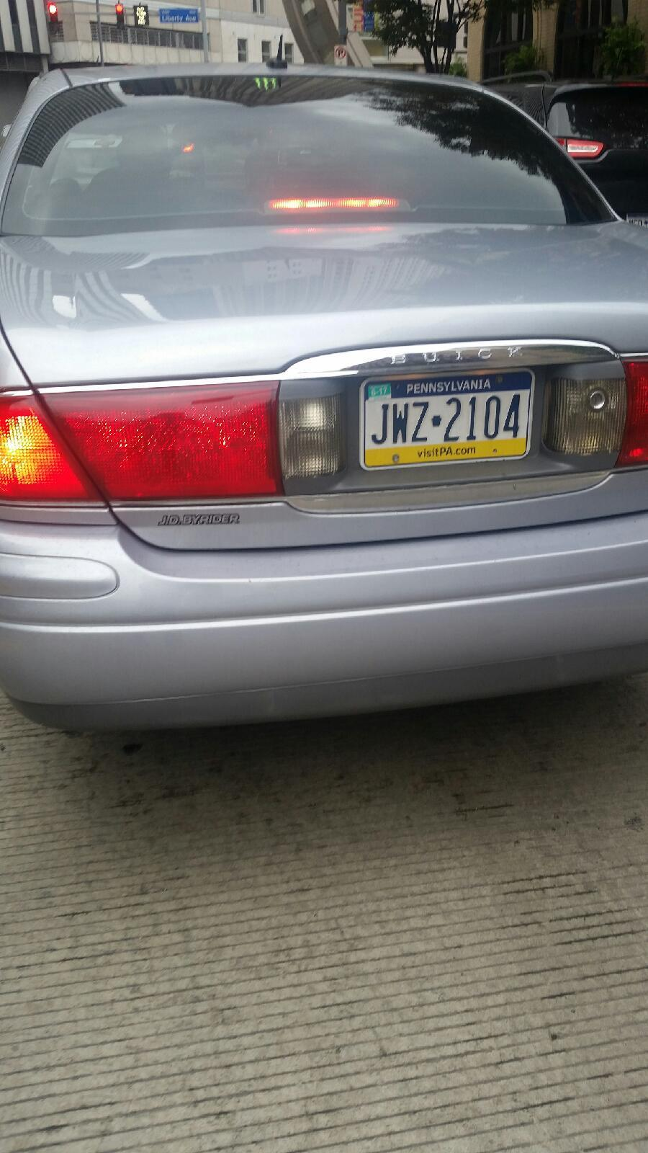

VERIFICATION

I, David W. Loucks, hereby state that the facts above set forth are true and correct to the best of my knowledge, information and belief and that I expect that the Bureau will be able to prove same at any hearing held in this matter. I understand that the statements herein are made subject to the penalties of 18 Pa. C.S. §4904 relating to unsworn falsification to authorities.

Date: 10/5/2016
David W. Loucks, Chief
Motor Carrier Enforcement
Bureau of Investigation and Enforcement

NOTICE
A. You must file an Answer within twenty (20) days of the date of service of this Complaint. The date of service is the mailing date as indicated at the top of the Secretarial Cover Letter for this Complaint and Notice, 52 Pa. Code §1.56(a). An Answer is a written explanation of circumstances wished to be considered in determining the outcome. The Answer shall raise all factual and legal arguments that you wish to claim in your defense and must include the reference number of this Complaint. Your Answer must be verified and the original shall be mailed to:

Rosemary Chiavetta, Secretary
Pennsylvania Public Utility Commission
P.O. Box 3265
Harrisburg, Pennsylvania 17105-3265

Or may be sent by overnight delivery to:
400 North Street, 2nd Floor
Harrisburg, Pennsylvania 17120

Additionally, please serve a copy on:

Michael L. Swindler, Deputy Chief Prosecutor
Bureau of Investigation and Enforcement
Pennsylvania Public Utility Commission
P.O. Box 3265
Harrisburg, Pennsylvania 17105-3265

Or, e-mailed to Mr. Swindler at: RA-PCCmplntResp@pa.gov

B. If you fail to answer this complaint within twenty (20) days, the Bureau of Investigation and Enforcement will request that the Commission issue a Secretarial Letter imposing a penalty. The penalty could include a fine, the suspension or revocation of your certificate of public convenience or other remedy.

C. You may elect not to contest this complaint by paying the fine proposed in this Complaint by certified check or money order. Payment must be made to the Commonwealth of Pennsylvania and should be forwarded to:

Rosemary Chiavetta, Secretary
Pennsylvania Public Utility Commission
P.O. Box 3265
Harrisburg, PA 17105-3265

Your payment is an admission that you committed the alleged violation and an agreement to cease and desist from further violations. Upon receipt of your payment, the complaint proceeding shall be closed.

D. If you file an Answer, which admits or fails to deny the allegations of the Complaint, the Bureau of Investigation and Enforcement will request that the Commission issue a Secretarial Letter imposing a penalty.

E. If you file an Answer which contests the Complaint, the matter will be assigned to an Administrative Law Judge for hearing and decision. The judge is not bound by the optional fine set forth above.

F. Alternative formats of this material are available for persons with disabilities by contacting the Commission’s ADA Coordinator at 717-787-8714.

