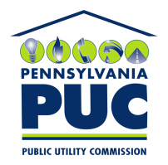 | COMMONWEALTH OF PENNSYLVANIA  PENNSYLVANIA PUBLIC UTILITY COMMISSION  400 North Street, Keystone Building, Second Floor  Harrisburg, Pennsylvania 17120 | IN REPLY PLEASE REFER TO OUR FILE
October 17, 2016

Jim Charron
Avion Energy Group LLC
1475 Buford Drive Suite 403-186
Lawrenceville GA 30043

RE: Bond Continuation Certificate
Avion Energy Group LLC
Docket Number A-2013-2396660

Dear Mr. Charron:

Please find under cover of this letter the financial instrument filed on behalf of Avion Energy Group LLC because it is not acceptable.

The Commission requires a supplier to file an original bond, letter of credit, continuation certificate, amendment, or other financial instrument as part of a supplier’s licensing requirements under Section 2809(c) of the Pennsylvania Public Utility Code, including naming the Pennsylvania Public Utility Commission as the beneficiary or obligee of the security instrument along with all other required information on the document.

The enclosed Continuation Certificate does not name “Pennsylvania Public Utility Commission” as the Obligee.

Please file the corrected, originally signed and sealed security instrument with my office within 20 days of the date of this letter, preferably by overnight delivery.

Sincerely,

Rosemary Chiavetta
Secretary of the Commission

Enclosures
RC:alw

