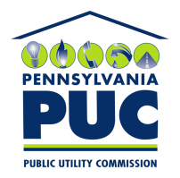 | COMMONWEALTH OF PENNSYLVANIA  PENNSYLVANIA PUBLIC UTILITY COMMISSION  400 North Street, Keystone Building, Second Floor  Harrisburg, Pennsylvania 17120 | IN REPLY PLEASE REFER TO OUR FILE

October 27, 2016

IntelliGEN Resources LP
403 Koldin Drive
Aledo TX 76008

RE: Duplicate Financial Instrument
IntelliGEN Resources LP
A-2010-2210786

Dear Sir/Madam:

Please find under cover of this letter the Continuation Certificate your company filed with the Commission on behalf of IntelliGEN Resources LP because it is a duplicate of the financial instrument already on file.

The Commission requires a supplier to file a current and active original bond, letter of credit, continuation certificate, amendment, or other financial instrument as part of a supplier’s licensing requirements under Section 2809(c) of the Pennsylvania Public Utility Code.

While your financial instrument filed with the Commission expires on September 30, 2017, please note that it does not include the required updates to the Financial Security language.

Sincerely,

Rosemary Chiavetta
Secretary of the Commission

Enclosures
RC:alw

