BEFORE THE
PENNSYLVANIA PUBLIC UTILITY COMMISSION

Gail Gassette :
:
v. : F-2016-2551097
:
Duquesne Light Company :

INTERIM ORDER CLOSING THE HEARING RECORD

AND NOW, the telephonic hearing having been conducted on October 6, 2016, on the Complaint filed by Gail Gassette against Duquesne Light Company at Docket Number F-2016-2551097, and the transcript of the hearing having been received on October 31, 2016, and no further hearings in this matter are to be scheduled or held,

THEREFORE,

IT IS ORDERED:

- That the hearing record at Docket Number F-2016-2551097 is closed.

2. That the Initial Decision in this case shall be prepared and issued.

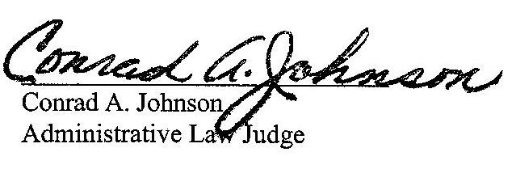
Dated: November 2, 2016

F-2016-2551097 GAIL GASSETTE V. DUQUESNE LIGHT COMPANY

Gail Gassette
400 Oakhill Drive
Apartment 413
Pittsburgh PA 15213
(412) 904-4616

Jeremy V Farrell Esquire
Lauren N Woleslagle Esquire
Tucker Arensberg PC
1500 One PPG Place
Pittsburgh PA 15222
(412) 594-5527
ACCEPTS E-SERVICE

