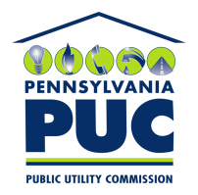 | COMMONWEALTH OF PENNSYLVANIA  PENNSYLVANIA PUBLIC UTILITY COMMISSION  400 North Street, Keystone Building, Second Floor  Harrisburg, Pennsylvania 17120 | IN REPLY PLEASE REFER TO OUR FILE

November 8, 2016

Don Patch
Patch Energy Services LLC
11030 Martha Ann Court
Fairfax Station VA 22039

RE: Bond Continuation Certificate
Patch Energy Services LLC
A-2011-2221397

Dear Mr. Patch:

Please find under cover of this letter the updated financial instrument you filed with the Commission on behalf of Patch Energy Services LLC because it is a copy and not acceptable.

The Commission requires a supplier to file an original bond, letter of credit, continuation certificate, amendment, or other financial instrument as part of a supplier’s licensing requirements under Section 2809(c) of the Pennsylvania Public Utility Code.

The enclosed Continuation Certificate does not have a "wet ink" original signature or raised seal. As a new signed and sealed bond with an expiration date of October 25, 2017 was also filed for Patch Energy Services LLC, no further action on your part is required at this time.

Sincerely,

Rosemary Chiavetta
Secretary of the Commission

RC: alw
Enclosures

