BEFORE THE
PENNSYLVANIA PUBLIC UTILITY COMMISSION

Jeffrey D. Wellborn :
:
v. : C-2016-2559492
:
Pennsylvania-American Water Company :

INTERIM ORDER
CLOSING THE HEARING RECORD

AND NOW, the transcript of the November 4, 2016 initial hearing in this case having been filed with the Commission’s Secretary’s Bureau in Harrisburg on November 30, 2016; and a copy of the transcript having been received by the undersigned in Pittsburgh on December 6, 2016; and no further hearings in this matter are to be scheduled or held,

THEREFORE,

IT IS ORDERED:

- That the hearing record at Docket No. C-2016-2559492 is closed.

2. That the Initial Decision in this case shall be prepared and issued.

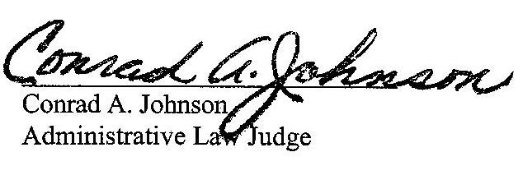
Dated: December 7, 2016

C-2016-2559492 - JEFFERY D WELLBORN v. PENNSYLVANIA AMERICAN WATER COMPANY
JEFFERY D WELLBORN
9944 POSSUM HOLLOW ROAD
SHIPPENSBURG PA 17257
717.870.9340
MICHAEL A GRUIN ESQUIRE
STEVENS & LEE
16TH FLOOR
17 NORTH SECOND STREET
HARRISBURG PA 17101
717.255.7365
Accepts E-Service

